***Arab American University***

***Faculty of Engineering and Information Technology***

***Computer Systems Engineering***

**SENIOR PROJECT 1**

*Medical Semi-Automated System for Injectable Drugs*

*2022/2023*

|  |
| --- |
| ***Supervised by: Dr. Rami Hadrob*** |

|  |
| --- |
| **Computer Systems Engineering Dept.**  **Submitted in partial fulfillment of the requirements of B.Sc. Degree in Computer Systems Engineering**    ***1/12/2022*** |

**Students Statement**

We, the undersigned students, certify and confirm that the work submitted in this project report is entirely our own and has not been copied from any other source. Any material that has been used from other sources has been properly cited and acknowledged in the report.

We are fully aware that any copying or improper citation of references/sources used in this report will be considered plagiarism, which is a clear violation of the Code of Ethics of the Arab American University.

***Medical Semi-Automated System for Injectable Drugs***

**Supervisor Certification**

This to certify that the work presented in this senior year project manuscript was carried out under my supervision, which is entitled:

**“Medical Semi-Automated System for Injectable Drugs”**

|  |  |
| --- | --- |
| ​*Shoaib Jadallah (201810798)* | ​*Majdi Hoseen (201610180)* |
| ​*Hiba Hanaysheh (201811178)* | ​ |

I hereby that the aforementioned students have successfully finished their senior year project and by submitting this report they have fulfilled in partial the requirements of B.Sc. Degree in Computer System Engineering.

I also, hereby, have **read, reviewed and corrected the technical content** of this report and I believe that it is adequate in scope, quality and content and it is in alignment with the ABET requirements and the department guidelines.

Dr. Rami

**ACKNOWLEDGMENT**

We would like to thank our families and friends who provided support and assistance to us during our study years and the working period of this project.

We would like to seize this opportunity to express our deep appreciation to Dr. Rami Hadrob for his advice, support and time which has been spent reviewing our work. He provided valuable suggestions. Which have had a great impact and have helped in overcoming many obstacles in writing this project in the best way.

Also, we wish to thank the teachers and faculty members of the Computer Systems Engineering Department at the Arab American University-Palestine for their help during our study years in the university.

Thanks for all your encouragement!

# ABSTRACT

This system aims to address the issue of patient wait times and potential mismanagement of medication in hospitals. The system consists of two parts: a hardware component implemented with Arduino that delivers the medication to the patient and a software application that allows doctors to remotely manage the patient list and initiate treatment. The goal is to provide a solution that ensures patients receive their medication on time and without delay, reducing the risk of adverse events.

Any hospital is under the risk of patients highly increase, has a condition that their doctors will be late or busy and all of these hospitals could have patients who need to take their medicine periodically and at the right time. However, this delay may lead the patients to a painful or dangerous situation, because they have difficulty with taking these drugs when they need it.

To effectively solve this problem, we will implement a system that takes the place of the doctor temporarily.

# Contents

ABSTRACT 5

Contents 6

List of tables 9

List of figures 10

LIST OF SYMBOLS AND ABBREVIATIONS 12

CHAPTER 1: INTRODUCTION 1

1.1 Problem Statement and Purpose 1

1.2 Project Objectives 1

1.3 Design Objectives 1

1.4 Intended Outcomes and Deliverables 1

1.5 Summary of Report Structure 1

CHAPTER 2: BACKGROUND 2

2.1 Overview 2

2.2 Related Work 2

2.2.1 INFUSION PUMP 2

2.2.2 Injection pump device 3

2.2.3 Water Level Sensor with Arduino. 4

2.2.4 Controlling submersible pump with Arduino 5

2.2.5 INFUSION PUMP Model: HK-100I 6

2.2.6 ESP32 & DS3231 Based Real Time Clock (RTC) on OLED 7

CHAPTER 3: METHODS AND MATERIALS 10

3.1 System Design and Components 10

3.1.1 Breadboard 10

3.1.2 Diode 10

3.1.3 Resistor 11

3.1.4 Wires 11

3.1.5 Case Box 11

3.1.6 Transistors 11

3.1.7 LED 12

3.1.8 Active Buzzer 12

3.1.9 Pump 5V 12

3.1.10 Arduino Uno R3 13

3.1.11 ESP32 13

3.1.12 Water level sensor 14

3.1.13 Power supply 5V 15

3.1.14 Power supply 12v 15

3.1.15 L298N DC Motor Driver 16

3.1.16 TM1637 16

3.1.17 DS3231 17

3.1.18 MAXELL ML2032 ML 2032 3v RECHARGEABLE LITHIUM BATTERY 17

3.1.19 Android Studio 17

3.1.20 Visual Studio Code 18

3.1.21 Draw.io 19

3.1.22 Fritzing 19

3.1.23 Figma 20

3.1.24 LCD i2C 20

3.1.25 ultrasonic sensor 20

3.1.26 DHT11 21

3.2 Design Specifications, Standards and Constraints 21

3.2.1 Web APPLICATION DESIGN 21

3.2.2 Design standards 22

3.2.3 Design constraints 22

3.2.4 System Requirements 22

3.2.5 Non-Functional Requirements 26

3.2.5.1 Ease of Use 26

3.2.5.2 Portability 26

3.2.5.3 Affordability 26

3.2.5.4 Accuracy 26

3.2.5.5 Security 26

3.2.6 User Requirements 26

3.3 Design Alternatives 27

3.4 Web application and system flowchart 32

3.4.1 Application flowchart 32

3.4.2 system flowchart 33

3.5 Use-Case Diagram 34

3.6 State Diagram 36

3.7 Sequence diagram: 38

3.8 ERD (Entity Relationship Diagram): 41

3.9 UML class diagram 45

3.10 System Analysis and Optimization 46

CHAPTER 4: RESULTS AND DISCUSSIONS 47

4.1 Results 47

4.2 Discussions 53

CHAPTER 5: Project Management 54

5.1 Tasks, Schedule and Milestones 54

5.2 Resources and Cost Management 57

5.3 Lessons Learned 58

CHAPTER 6: Impact of the engineering solution 59

6.1 Economical, Societal and Global 59

6.2 Environmental and Ethical 59

6.3 Other Issues 59

CHAPTER 7: CONCLUSIONS and RECOMMENDATIONS 60

7.1 Summary of Achievements of the Project Objectives 60

7.2 New Skills and Experiences Learnt 60

*7.3* Recommendations for Future Work 60

REFERENCES 61

APPENDICES 63

Appendix 1: Temperature compensated crystal oscillator 63

Appendix 2: Arduino Uno Pinout - Diagram 64

Appendix 3:-L298N driver motor 65

Appendix 4:- DS3231 RTC module 66

# List of tables

Table 1:list of symbols 12

Table 2:ESP32 & DS3231 Based Real Time Clock (RTC) on OLED component 8

Table 3:Comparison between related works 9

Table 4:cost of senior project items 58

Table 5:DS3231 Pins Description 67

# List of figures

Figure 1:INFUSION PUMP 2

Figure 2:Injection pump device 3

Figure 3:Water Level Sensor with Arduino []. 4

Figure 4:Controlling submersible pump with Arduino 6

Figure 5:INFUSION PUMP Model: HK-100I 7

Figure 6:ESP32 & DS3231 Based Real Time Clock (RTC) on OLED connection. 8

Figure 7:Breadboard 10

Figure 8:Diode 10

Figure 9:Resistor 11

Figure 10:Wires 11

Figure 11:Transistors 11

Figure 12::LED 12

Figure 13:Buzzer 12

Figure 14:Pump 13

Figure 15:Arduino Uno R3 schematic 13

Figure 16:ESP32 schematic 14

Figure 17: water level sensor connection 14

Figure 18: water level sensor pinout 15

Figure 19: power supply 5V 15

Figure 20:Power supply 12v 15

Figure 21:L298N DC Motor Driver 16

Figure 22:TM1637 16

Figure 23:DS3231 17

Figure 24:MAXELL ML2032 ML 2032 3v RECHARGEABLE LITHIUM BATTERY 17

Figure 25:Android Studio program. 18

Figure 26:Visual Studio Code program. 18

Figure 27:Draw.io program. 19

Figure 28:Fritzing program. 19

Figure 29:Figma website 20

Figure 30:LCD i2C 20

Figure 31:ultrasonic sensor 21

Figure 32:DHT11 21

Figure 33::Design 1 28

Figure 34::Design 2 29

Figure 35::Design 3 30

Figure 36:Design 4 31

Figure 37:Design 5 32

Figure 38:application flowchart 33

Figure 39:system flowchart 34

Figure 40:user U.C Diagram 35

Figure 41:admin U.S Diagram 36

Figure 42:state diagram. 37

Figure 43:state diagram 2. 38

Figure 44:login page sequence diagram. 39

Figure 45:Profile page sequence diagram. 40

Figure 46:Editing profile data sequence diagram. 40

Figure 47:Make process sequence diagram. 41

Figure 48:Entity relationships diagram. 42

Figure 49:User E.R Diagram. 43

Figure 50:Patients E.R Diagram. 43

Figure 51:Admin E.R Diagram. 44

Figure 52:Manage E.R Diagram 44

Figure 53:Process E.R Diagram. 45

Figure 54:Hospital E.R Diagram. 45

Figure 55:UML class diagram 46

Figure 56:design 3 connection 1 49

Figure 57:design 3 connection 2 49

Figure 58:design 3 results 2 Figure 59:design 3 results 1 50

Figure 60:Realtime database results 50

Figure 61:final design 1 51

Figure 62:final design 2 52

Figure 63:final design 3 52

Figure 64:final design 4 53

Figure 65:final design 5 53

Figure 66:final design 6 54

Figure 67:schedule part A 55

Figure 68:schedule part B 55

Figure 69:schedule part C 56

Figure 70:schedule part D 56

Figure 71:schedule part E 57

Figure 72:schedule part F 57

Figure 73:Arduino UNO R3 pinout 65

Figure 74:L298N 66

Figure 75:DS3231 67

# LIST OF SYMBOLS AND ABBREVIATIONS

Table :list of symbols

|  |  |
| --- | --- |
| **LIST OF SYMBOLS** | |
| **Ω** | Ohm |
|  |  |
|  |  |
| **LIST OF ABBREVIATIONS** | |
| **ABET** | Accreditation Board for Engineering and Technology |
| **AC** | Alternating Current |
| **ADC** | Analog-to-Digital Converter |
| **AREF** | Analog Reference |
| **BJT** | Bi-polar Junction Transistor |
| **CAN** | Controller Area Network |
| **CLK** | Clock |
| **CPU** | Central Process Unit |
| **DAC** | Digital-to-Analog Converters |
| **DC** | Direct Current |
| **EN** | Enable |
| **ESP32** | [Espressif Systems](https://en.wikipedia.org/w/index.php?title=Espressif_Systems&action=edit&redlink=1) (name of the manufactured) |
| **FTDI** | Future Technology Devices International Limited |
| **GPIO** | General-Purpose Input/Output |
| **Hz** | Hertz |
| **I2C** | Inter-Integrated Circuit |
| **IC** | Integrated Circuit |
| **ICSP** | In-Circuit Serial Programming |
| **IDE** | Integrated Development Environment |
| **INF** | Setup Information File |
| **IOREF** | Input Output Voltage Reference |
| **IP** | Internet Protocol |
| **K** | Kilo |
| **LCD** | Liquid Crystal Display |
| **LED** | Light-Emitting Diode |
| **M-F** | Male to Female |
| **M-M** | Male to Male |
| **OLED** | Organic Light-Emitting Diode |
| **PWM** | Pulse-Width Modulation |
| **RTC** | Real-Time Clock |
| **SCK** | Serial Peripheral Interface Clock |
| **SD** | Secure Digital (memory) |
| **SCL** | Serial Clock |
| **SDA** | Serial Data |
| **SPI** | Serial Peripheral Interface |
| **SQW** | Square Wave output pin |
| **TCXO** | Temperature compensated crystal oscillator |
| **TCP** | Transmission Control Protocol |
| **TTL** | Transistor-Transistor Logic |
| **UART** | Universal Asynchronous Receiver-Transmitter |
| **UI** | User Interface |
| **UML** | Unified Modeling Language |
| **USB** | Universal Serial Bus |
| **UX** | User Experience |
| **V** | Volte |

# CHAPTER 1: INTRODUCTION

## 1.1 Problem Statement and Purpose

With the progress of life, man has become highly dependent on machines and technology

Which required engineers to develop these machines to suit human needs with the development of technology, new and dangerous viruses were born as well. So, there are new challenges facing our doctors and nurses, which create great pressures that may lead to neglect of how to give liquid medicines intravenously in terms of quantity and type, especially that these medicines have no color. This leads to serious physical complications and can lead to death in some cases.

## 1.2 Project Objectives

* Provide immediate assistance to patients remotely.
* Develop a mobile app to control the healing process from it.
* Help patients to save their lives, In emergency situations.
* Save effort and time & Reduce the medical errors.
* Providing medical services to people with special needs in their homes without the need to come to the hospital for treatment.

## 1.3 Design Objectives

* We plan to build a half-automated Robot that can transfer drugs Intravenous.
* Develop a web application to see the patients, Patient details and provide all the needed drugs for every one of them from that application.
* The robot will give the medicine at the right time and quantity according to the patient’s need.

## 1.4 Intended Outcomes and Deliverables

* Provide more time for the nurse to be free for immediate situations.
* Reduce the medical errors that may lead to serious complications and sometimes even death.

## 1.5 Summary of Report Structure

In chapter 2, We will present a review of existing work in the field and provide context for our solution. In chapter 3, We will detail the design of our solution, including components, flowcharts, Requirements, and diagrams. In chapter 4, We will present and analyze the results of your work. Chapter 5 will focus on the cost and schedule of our project, While chapter 6 will examine the impact of our solution. Finally, in chapter 7, We will provide a conclusion summarizing the key takeaways and future directions for our work.

# CHAPTER 2: BACKGROUND

## 2.1 Overview

In this chapter, we will discuss existing systems that have similarities in functionality to our project. Although our project idea is partially new, there are other projects with similar aims. Our system aims to aid doctors and nurses in their work by allowing them to efficiently manage patients and monitor their drug providing. We hope that the system we develop will be beneficial for healthcare professionals in all hospital departments. We will highlight some relevant projects and examine their advantages and disadvantages.

## 2.2 Related Work

### 2.2.1 INFUSION PUMP

An external infusion pump is a medical device used to deliver fluids into a patient's body in a controlled manner.[1]

**Features of the App:**

**· For officials:**

1. Reducing time and effort.

2. multi-purpose machines and in a variety of environments

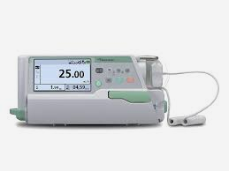

Figure :INFUSION PUMP

**· For patients:**

1. The device is accessible to every patient.
2. It is conveniently located next to the patient's bed for constant monitoring.
3. The device is also designed to be portable and wearable for mobility.

**The following features:**

The device is capable of delivering liquids in both large and small quantities. It can be used to administer nutrients, medications such as insulin, antibiotics, chemotherapy drugs, and pain relievers.

**Disadvantages of the device:**

This device does not have an alarm system to alert the user in case of malfunctions, low battery, open cover, bend in the hose, air bubbles, or low liquid levels. However, these features will be included in our accompanying app.

### 2.2.2 Injection pump device

The syringe pump is a compact device that delivers drugs through continuous, regulated intravenous injection. It operates based on pressure and is equipped with a valve and specialized tubing. The device pushes a liquid solution at a controlled pressure. It is equipped with a bacterial filter to prevent contamination and infection. The solution can be programmed to ensure appropriate delivery [2].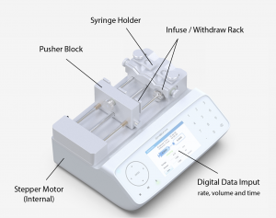

Figure :Injection pump device

**Disadvantages of the device**

The size of the syringe used determines the volume of fluid delivered. Excessive resistance can result in pressure buildup and potential failure of the injection pump. Without flow sensors, it is not possible to accurately determine the flow rate during transitional periods. However, our application allows the user to monitor the amount of medicine entering the patient's body, which is predetermined within the application. The application is also able to deliver the appropriate amount of medicine at a controlled pressure.

### 2.2.3 Water Level Sensor with Arduino.

Water level sensors are utilized in various applications to monitor the levels and flow of water, such as in tanks for irrigation systems, swimming pools, and fish ponds. In this tutorial, I will demonstrate how to interface this type of sensor with an Arduino board.[3]

**How does the water level sensor work?**

This sensor detects water levels by sensing the conductivity of the water it is submerged in. The conductivity of water is dependent on the presence of impurities, so pure water is not conductive.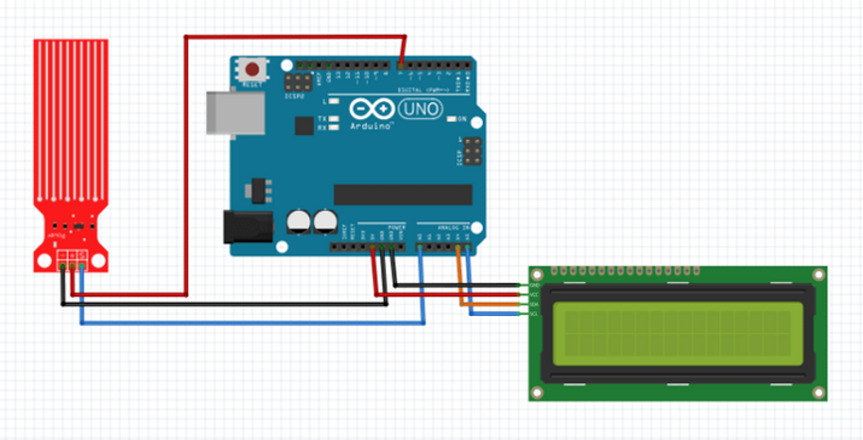

Figure :Water Level Sensor with Arduino [].

**Components:**

* Arduino UNO R3
* LCD I2C (IIC)
* water sensor
* Weirs
* 9V DC voltage source

**How the project helps us:**

The purpose of the project is to accurately measure the amount of drug being delivered and display it on an LCD screen or 7-segment display. If the volume in the tube drops below a certain level, the system will activate an alarm sound, turn on a red LED, and send an error message to the associated application to alert the user of any issues.

### 2.2.4 Controlling submersible pump with Arduino

**Background**

Submersible pumps are useful for managing the flow of water. When combined with an Arduino microcontroller, these pumps can automate the water distribution process, making them suitable for applications such as aquariums, fountains, and irrigation, refill, and aeration systems. In this tutorial, we will demonstrate how to use an Arduino Uno to control a submersible pump. The first example will show how to control the flow based on timed intervals, and the second example will demonstrate how to control the flow based on feedback from a sensor..[4]

**Components**

Below is a list of the required components:

1. [Arduino Uno microcontroller](https://store-usa.arduino.cc/products/arduino-uno-rev3) (or equivalent board) (x1)

2. [DC 3V 5V Micro Submersible Mini Water Pump](https://www.amazon.com/Gikfun-Submersible-Fountain-Aquarium-EK1893/dp/B07BHD6KXS/ref=sr_1_1?crid=3FJA3UXLWPOFV&keywords=Submersible+3V+DC+Water+Pump+with+1+Meter+Wire&qid=1648392574&sprefix=submersible+3v+dc+water+pump+with+1+meter+wire+%2Caps%2C146&sr=8-1) (or equivalent) (x1)

3. [Mosfet transistor IRF520](https://www.mouser.com/ProductDetail/Infineon-IR/IRF520NPBF?qs=9%252BKlkBgLFf1C7AxBw5vizA%3D%3D&mgh=1&gclid=CjwKCAjw0a-SBhBkEiwApljU0sgNvwkn8JXc3pztx-7yeGubMUsDgFW7q2lYZS-tS2RmMf5KgEKxJhoCH9EQAvD_BwE) (or equivalent) (x1)

4. [Rectifier diode 1N4007](https://www.digikey.com/en/products/detail/onsemi/1N4007FFG/9086323?utm_adgroup=Discrete%20Semiconductor%20Products&utm_source=google&utm_medium=cpc&utm_campaign=Shopping_Supplier_onsemi&utm_term=&utm_content=Discrete%20Semiconductor%20Products&gclid=CjwKCAjw0a-SBhBkEiwApljU0j8CFJsPmWjku4XW5sNQlUJ571ZX9emL_RgFLhhQ_ZZ-zbLbwIUP0xoCoxYQAvD_BwE) (or equivalent) (x1)

5. [Photoresistor](https://www.digikey.com/en/products/detail/adafruit-industries-llc/161/7244927) – ambient light detector [HW5P-1](https://www.arduino.cc/documents/datasheets/HW5P-1.pdf) (or equivalent) (x1)

6. 10 kΩ (kiloohm) resistor (x1)

7. Breadboard (x1)

8. 9V battery + snap connector (x1)

9. M-M jumper wires (x8)

10. M-F jumper wires (x2)

11. A container with water to submerge the pump

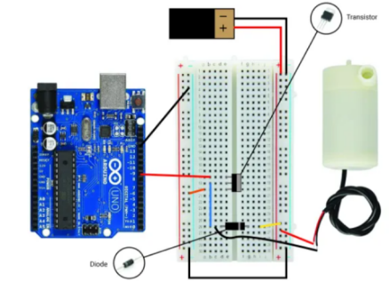

Figure :Controlling submersible pump with Arduino

**How the project helps us in my project:**

With the use of microcontrollers like Arduino, we can automate the process of controlling the pumps and make it more efficient. The system can monitor the flow rate and adjust it accordingly, it can also detect any anomalies and turn on an alarm or send an error message to alert the user. This helps in ensuring that the patient receives the correct amount of medicine at the right time, making the treatment process more effective.

### 2.2.5 INFUSION PUMP Model: HK-100I

It is used in hospitals where patient need intravenous infusion at preset infusion rate and volume limit [5]

**Components**

The Infusion Pump consists of five main components: the microcomputer system, pump body, detection device, alarm system, and input & display part. The microcomputer system acts as the brain of the system and provides intelligent control and management. The pump body, driven by a step motor, functions as the heart of the system and pumps the medical liquid. The detection device, consisting of sensors such as ultrasonic and pressure sensors, detects signals and transfers them to the microcomputer for processing. The alarm system, including a photoelectric alarm and audible alarm, alerts the user in case of any detected signals. Finally, the input & display part allows the user to set parameters and view them on the LCD screen.

This project may help us understand the errors and warnings that we may encounter in the pump system and how to deal with them or even avoid them in the first place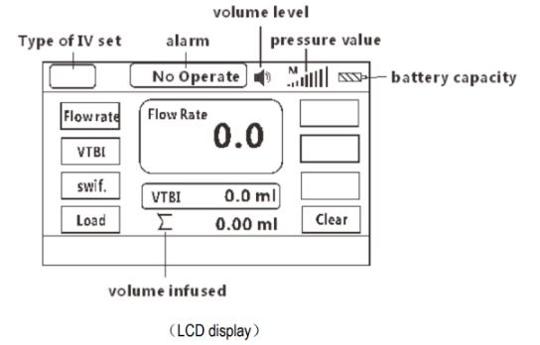

Figure :INFUSION PUMP Model: HK-100I

### 2.2.6 ESP32 & DS3231 Based Real Time Clock (RTC) on OLED

In this project, we will integrate the DS3231 Real Time Clock module with the ESP32 microcontroller and display the accurate time and date on a 0.96-inch I2C OLED display. [6]

**Bill of Materials: -**

Following are the components required for making this project. All the components can be easily purchased from Amazon. The purchase link is given as well.

Table :ESP32 & DS3231 Based Real Time Clock (RTC) on OLED component

|  |  |  |  |  |
| --- | --- | --- | --- | --- |
| **S.N** | **COMPONENTS NAME** | **DESCRIPTION** | **QUANTITY** | **References** |
| 1 | ESP32 Board | ESP32 ESP-32S Development Board (ESP-WROOM-32) | 1 | <https://amzn.to/2Vaz6JG> |
| 2 | RTC Module | DS3231 Real Time Clock Module | 1 | <https://amzn.to/3bCqK3z> |
| 3 | OLED Display | 0.96" SSD1306 I2C OLED Display | 1 | <https://amzn.to/2OZfswz> |
| 4 | Connecting Wires | Jumper Wires | 5 | <https://amzn.to/2L8Xc1p> |
| 5 | Breadboard | - | 1 | <https://amzn.to/2YM6YyS> |

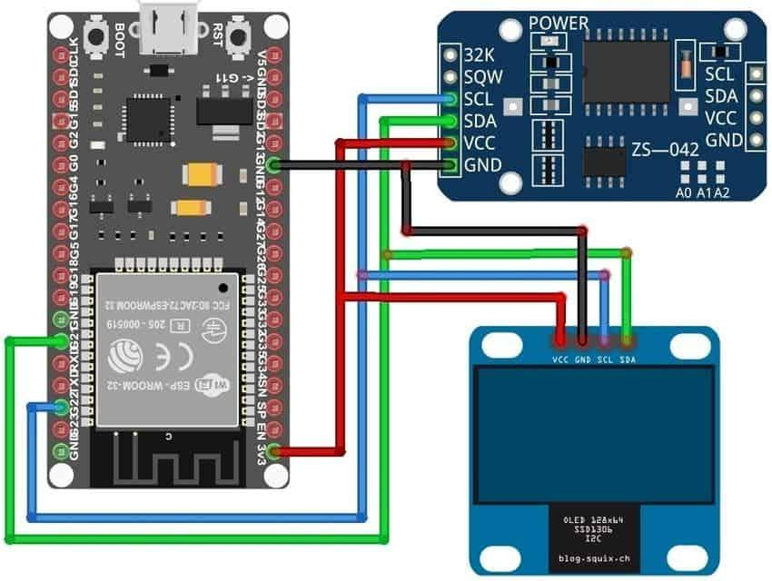

Figure :ESP32 & DS3231 Based Real Time Clock (RTC) on OLED connection.

**How can this project help us?**

In this project, we discovered how to interface the ESP32 with the DS3231, utilizing the latter to keep track of the accurate time and date. Our aim was to monitor the real-time and date accurately to ensure timely administration of liquid medicine.

Table :Comparison between related works

|  |  |  |  |  |  |  |  |
| --- | --- | --- | --- | --- | --- | --- | --- |
| Name of system  Differences | Senior I Medical Half Automated System  (This project) | INFUSION PUMP Model: HK-100II | Controlling submersible pump with Arduino | Water Level Sensor with Arduino | INFUSION PUMP | Injection pump device | ESP 32 and DS 3231Based Real Time Clock (RTC) on OLED |
| remote control | ✔️ | ✔️ | ✔️ | ✔️ |  |  | ✔️ |
| Contains an alarm | ✔️ |  |  |  |  |  |  |
| Real time System | ✔️ | ✔️ | ✔️ | ✔️ | ✔️ | ✔️ | ✔️ |
| It can be used in all countries | ✔️ | ✔️ | ✔️ | ✔️ | ✔️ | ✔️ |  |
| Cost | 600$ | 150$ | 120$ | 14$ | 400$ | 230$ | 100$ |
| Having a button to use | ✔️ | ✔️ |  |  | ✔️ | ✔️ | ✔️ |
| Linked to a web application | ✔️ |  |  |  |  |  |  |
| Measuring quantities | ✔️ | ✔️ | ✔️ | ✔️ | ✔️ | ✔️ | ✔️ |

# CHAPTER 3: METHODS AND MATERIALS

In this chapter of the project, we present the software design and hardware components utilized in the system, including their specifications, features, and architecture. We also provide an explanation of the methodology employed, the workings of the system, and the resolution of any encountered issues.

## 3.1 System Design and Components

In this part of the project, we will showcase the components utilized and highlight the features of each part in constructing the machine, as well as the UI/UX design of the accompanying application. We will describe the design and implementation approach, present flowcharts of the system, and include diagrams to aid comprehension.

### 3.1.1 Breadboard

A breadboard is a tool used in circuit design to prototype and test circuits quickly. It features numerous holes on its surface, allowing components like buttons and resistors to be easily inserted. The breadboard consists of metal strips underneath its surface, connecting the holes on top and arranged in a specific pattern as shown in the accompanying diagram. [7]

In our project, we will utilize a breadboard to secure the button.

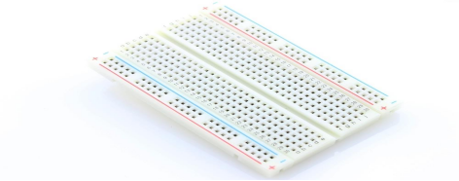

Figure :Breadboard

### 3.1.2 Diode

A diode is a two-terminal electronic component that facilitates the flow of electrical current in a single direction only. It has zero resistance when conducting current in its forward direction and infinite resistance in the opposite direction, provided it is within its specified operating voltage range. [8]

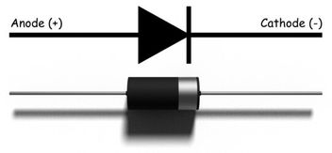

Figure :Diode

### 3.1.3 Resistor

Resistance is the hindrance to the flow of electrons in a material. It regulates the movement of electrons through a conductor by causing collisions between the electrons and ions within the metal, leading to the creation of resistance.[9]

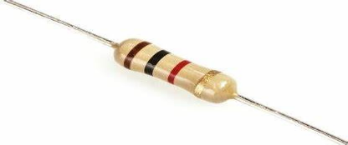

Figure :Resistor

### 3.1.4 Wires

A wire is a flexible metal conduit, typically made of copper, covered for protection and utilized to transmit electrical current in a circuit.

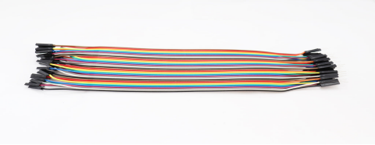

Figure :Wires

### 3.1.5 Case Box

The case box is the last piece in our project that we use to assemble all the components into a beautiful shape.

### 3.1.6 Transistors

Transistors play a crucial role in modern electronics, serving as control elements in almost every circuit. Though often unseen, they can be found both as standalone components and as integral parts of integrated circuits.10]

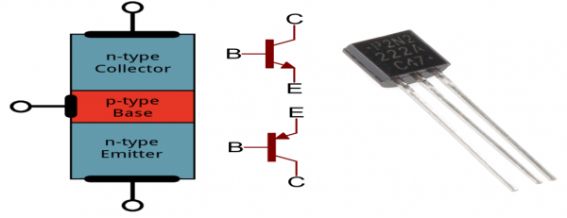

Figure :Transistors

### 3.1.7 LED

A light-emitting diode (LED) is a type of semiconductor that produces light when an electric current passes through it. This happens as electrons within the semiconductor recombine with electron gaps, releasing energy as photons. [11]

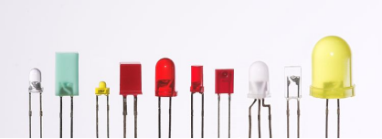

Figure ::LED

### 3.1.8 Active Buzzer

Active buzzers are named as such because they can independently generate sound by simply connecting to a power source. They generally emit a single, standardized tone of 2-KHz. In contrast, passive buzzers require an external triggering signal to produce sound, allowing for a range of different tones based on the frequency of the input. It is important to note that all buzzers have distinct positive and negative terminals, which must be connected to the corresponding positive and negative terminals of the power source for proper operation.[12]

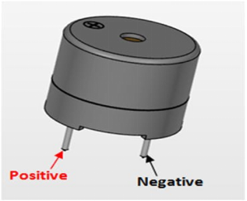

Figure :Buzzer

### 3.1.9 Pump 5V

This DC 5V Micro Submersible Water Pump can be easily incorporated into your water system project. The pump operates through a suction method, where it draws water in through the inlet and releases it through the outlet. [13]

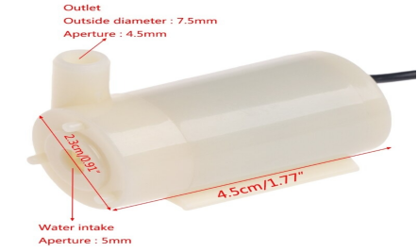

Figure :Pump

### 3.1.10 Arduino Uno R3

The new Arduino Uno R3 boasts several upgrades from previous models. It now utilizes an ATmega16U2 microcontroller for faster data transfer and increased memory capacity. No additional drivers are required for Linux or Mac, and the Uno can be programmed to act as a keyboard, mouse, joystick, or similar device. The Uno R3 also features newly added SDA and SCL pins, as well as two additional pins near the RESET pin: the IOREF pin that enables shields to adjust to the voltage provided by the board, and a reserved pin for future use. The Uno R3 is compatible with all existing shields and can accommodate new shields that utilize these additional pins. [14]

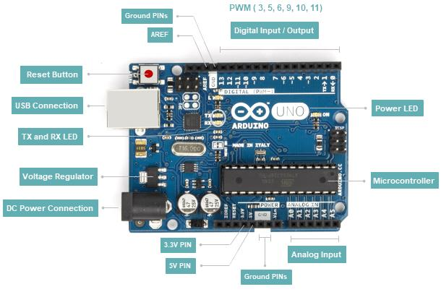

Figure :Arduino Uno R3 schematic

### 3.1.11 ESP32

The ESP32 is a low-power, cost-effective microcontroller that features integrated dual-mode Bluetooth and Wi-Fi. This versatile and reliable device is designed for a wide range of applications, including MP3 decoding, voice encoding, and music streaming. The ESP32 offers excellent RF and power performance, making it a top choice for these applications. With its built-in USB port, the ESP32 is a plug-and-play device that can be easily programmed, just like Arduino development boards. Later, we will delve into the specifics of programming this board. [15]

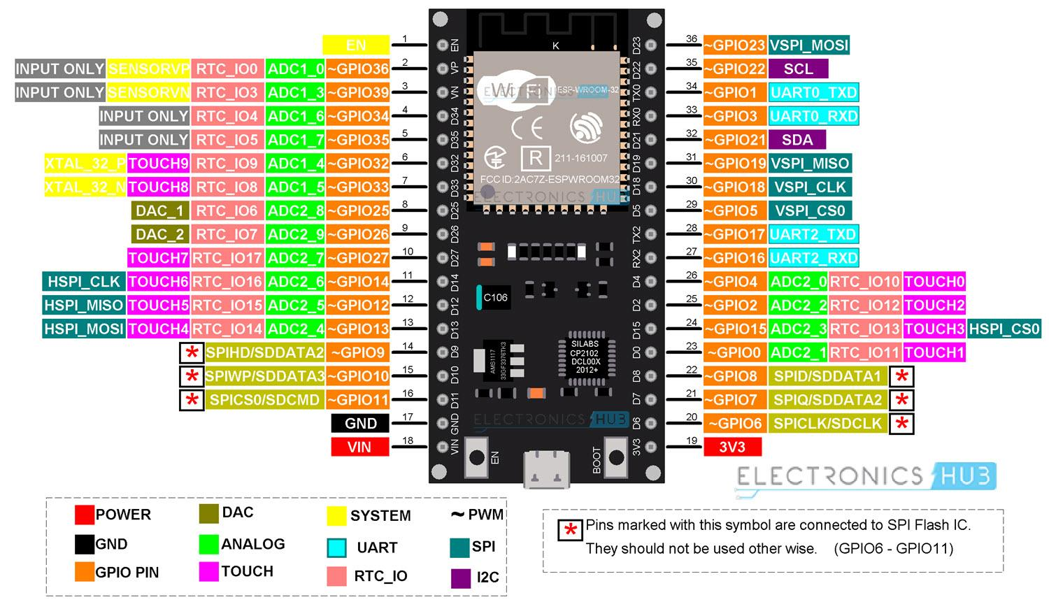

Figure :ESP32 schematic

### 3.1.12 Water level sensor

The water level sensor is a device that determines the height of liquid within a container. It can be classified into two categories based on the measurement method: contact and non-contact. The contact water level transmitter, also known as the input type, measures the liquid level by converting it into an electrical signal for output. This type of water level transmitter is widely used and prevalent in the industry [16]

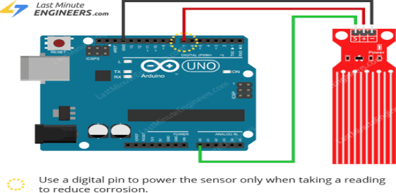

Figure : water level sensor connection

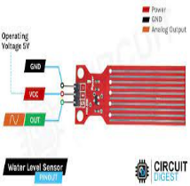

Figure : water level sensor pinout

### 3.1.13 Power supply 5V

5V power supplies, also known as 5V-DC power supplies, are widely used and prevalent in today's technology. To generate a 5V-DC output, a 50V-AC or 240V-AC input is transformed using a combination of transformers, diodes, and transistors. [17]

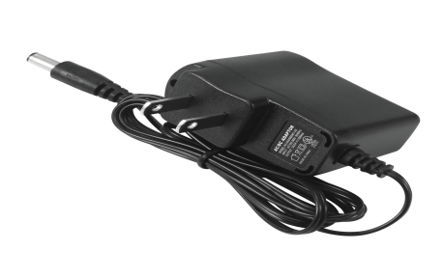

Figure : power supply 5V

### 3.1.14 Power supply 12v

A 12V-DC power supply is an electrical device that provides energy to a load. It operates by converting the source electric current into the desired voltage, frequency, and current, thereby powering the load.

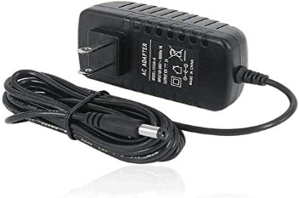

Figure :Power supply 12v

### 3.1.15 L298N DC Motor Driver

The L298N Motor Driver Module is a high-powered device designed for driving DC and stepper motors. The module features an L298 motor driver IC and a 78M05 5V regulator. It has the ability to control up to 4 DC motors or 2 DC motors with direction and speed control. [18]

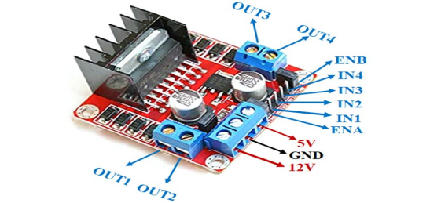

Figure :L298N DC Motor Driver

### 3.1.16 TM1637

The AVR library, designed specifically for driving 7-segment display modules, is a lightweight solution based on the TM1637 chip. This chip utilizes a unique 2-wire communication protocol, similar to I2C, but not compliant with the I2C standard. The library offers a software-based implementation of this communication method. [19]

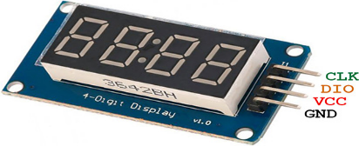

Figure :TM1637

### 3.1.17 DS3231

The DS3231 is a precise, low-cost I2C real-time clock (RTC) equipped with a temperature-compensated crystal oscillator (TCXO) and crystal. This device features a battery input, ensuring accurate timekeeping even when the main power supply is disrupted. [20]

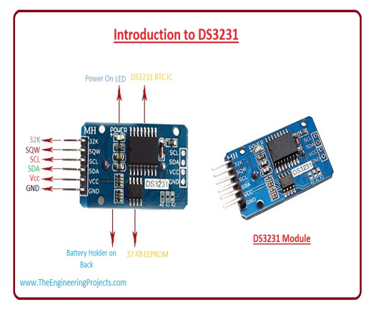

Figure :DS3231

### 3.1.18 MAXELL ML2032 ML 2032 3v RECHARGEABLE LITHIUM BATTERY

This battery is made up of lithium, flammable solvents, and other combustible materials. Improper handling of the battery may result in warping, leakage of fluid, overheating, explosions, or fires, causing harm to people or damaging equipment. To prevent accidents, it is important to follow the instructions provided. [21]

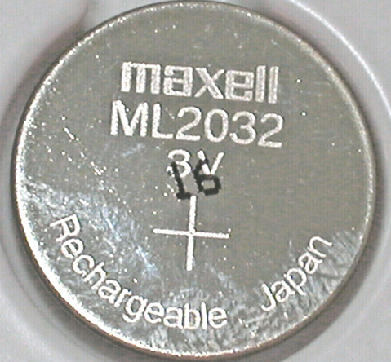

Figure :MAXELL ML2032 ML 2032 3v RECHARGEABLE LITHIUM BATTERY

### 3.1.19 Android Studio

Android Studio is the designated Integrated Development Environment for creating Android applications. Built on the feature-rich code editor and tools from IntelliJ IDEA, Android Studio offers additional functionality to improve your efficiency while developing Android apps. [22]

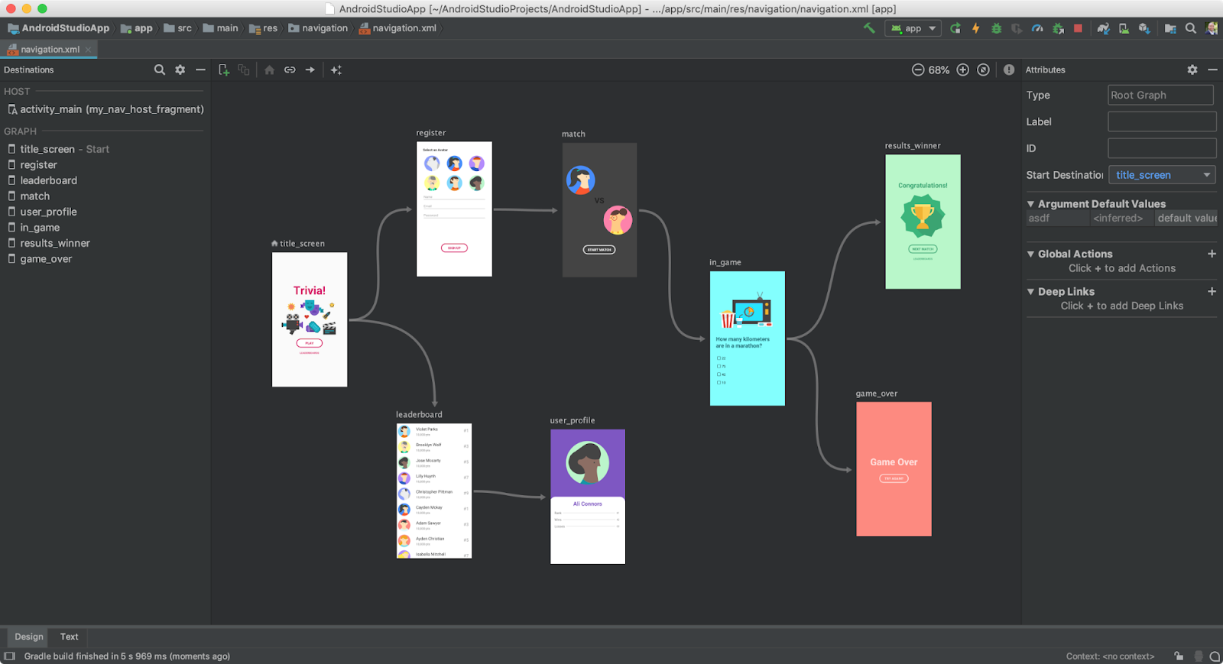

Figure :Android Studio program.

### 3.1.20 Visual Studio Code

Visual Studio Code offers a seamless blend of source code editing and advanced developer tools, much like IntelliSense's code completion and debugging capabilities. At its core, it is a minimalistic editor that prioritizes your productivity by streamlining the edit-build-debug process. This allows you to spend less time navigating through your development environment and more time focusing on turning your ideas into reality. [23]

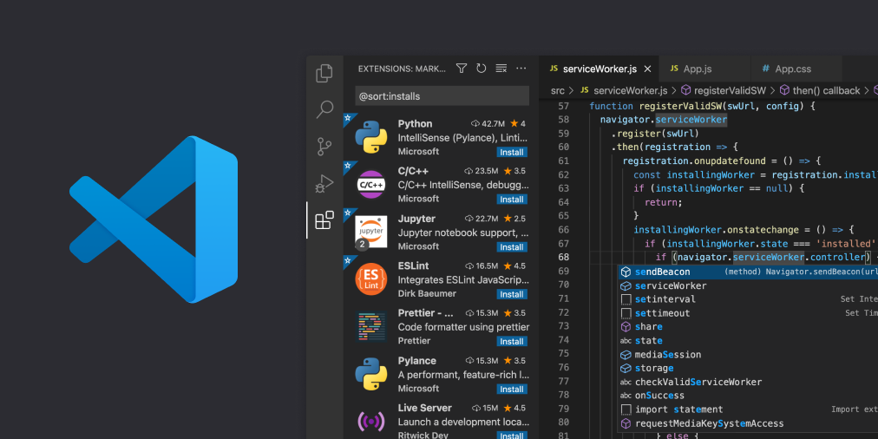

Figure :Visual Studio Code program.

### 3.1.21 Draw.io

Draw.io is a visually-appealing and user-friendly diagramming software created by Seibert Media. With its proprietary technology, users can easily create unique diagrams and charts that reflect their creativity and style. The software offers a wide range of customization options, including a comprehensive set of shapes and visual elements, and the convenience of a drag-and-drop interface. Whether opting for a custom design or an automatic layout, draw.io makes it effortless to bring your ideas to life with stunning visual representations. [24]



Figure :Draw.io program.

### 3.1.22 Fritzing

Fritzing is a free, open-source software developed at the University of Applied Sciences Potsdam. It is designed for amateur or hobbyists to design electronics hardware and to make more permanent circuits from prototypes. The software features an intuitive interface, drag-and-drop functionality and a vast library of shapes and visual elements, making it easy for designers and artists to create unique electronic designs. The source code for Fritzing is available on GitHub and binaries can be purchased at a cost, while still adhering to the GPL 3.0 or later license. [25]

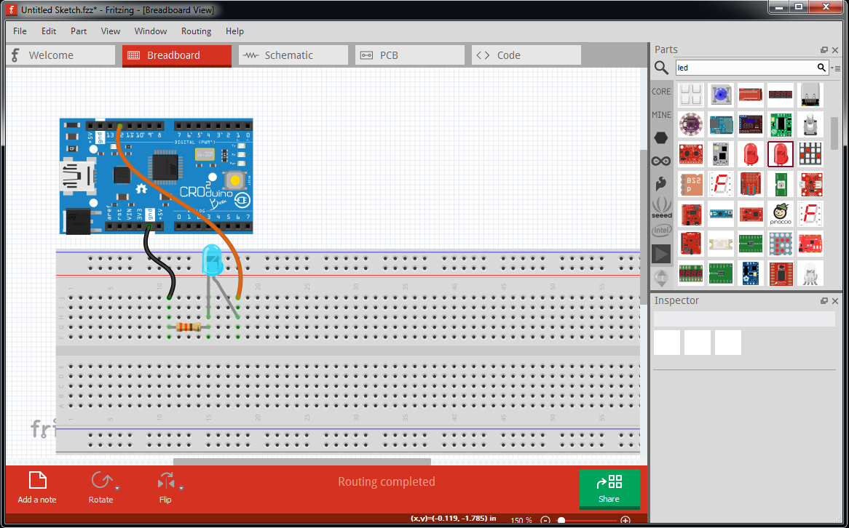

Figure :Fritzing program.

### 3.1.23 Figma

Figma is an innovative design platform that empowers you to create a diverse range of digital products, such as websites, apps, logos, and more. With Figma, you can master the key concepts of UI and UX design, which are crucial in building an impressive portfolio and elevating your design skills. This tool offers powerful features to help you bring your ideas to life and make them visually appealing. [26]



Figure :Figma website

### 3.1.24 LCD i2C

I2C LCD can be connected to the Arduino directly with SDA pin to SDA pin and SCL pin to SCL pin circuit diagram. I2C LCD requires additional library to be installed. communications and an adjustable potentiometer for changing the intensity of the LED backlight. An I2C LCD advantage is that wiring is straightforward, requiring only two data pins to control the LCD

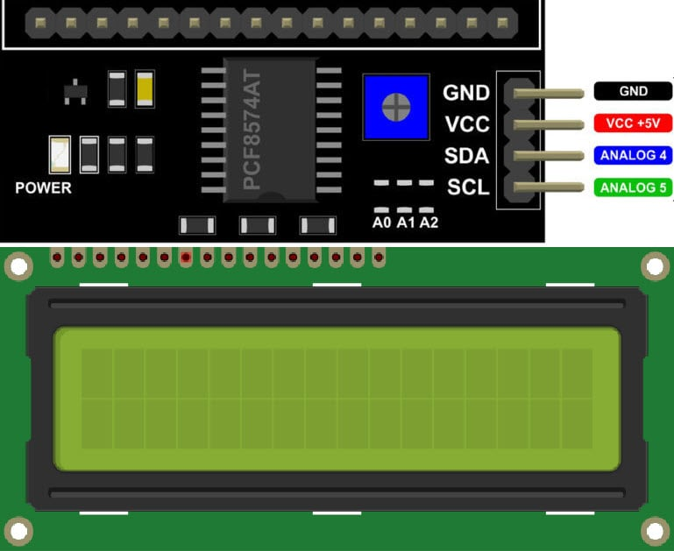

Figure :LCD i2C

### 3.1.25 ultrasonic sensor

An ultrasonic sensor is an electronic device that measures the distance of a target object by emitting ultrasonic sound waves, and converts the reflected sound into an electrical signal.

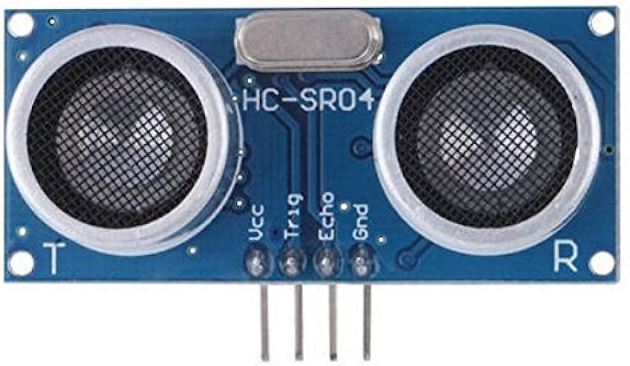

Figure :ultrasonic sensor

### 3.1.26 DHT11

The DHT11 is a commonly used Temperature and humidity sensor that comes with a dedicated NTC to measure temperature and an 8-bit microcontroller to output the values of temperature and humidity as serial data.

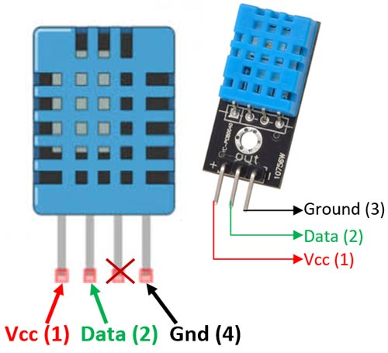

Figure :DHT11

## 3.2 Design Specifications, Standards and Constraints

### 3.2.1 Web APPLICATION DESIGN

In our project, we aim to develop a web application to assist doctors and nurses in monitoring and managing patients and their medications, including the quantity and timing, using wireless technology such as Wi-Fi. This technology is preferred over Bluetooth for its greater range of information reception. The application will also feature icons and images on most screens to enhance its ease of use for medical professionals.

### 3.2.2 Design standards

1. ISO 9001: standardized quality management guideline. (Followed by ABET).
2. UART: A hardware communication protocol.
3. TCP/IP protocol.
4. I2C protocol.
5. ISO 11898-1 (CAN Specification 2.0) protocol
6. Using the internet to communicate with the ESP-32.
7. We are using the Arduino because all sensors must have a low power
8. The project cost does not exceed 2000$.
9. The device does not weigh more than 3kg.
10. Able to give the results of object detection in a very short time, not exceeding a minute.
11. TTL serial communication.

### 3.2.3 Design constraints

* The main challenge we faced was connecting the device to the application and transmitting data from the application to the device.
* Arduino Uno R3: ● The power supply should be between 2.7V and 5V. ● Each pin can provide or sink up to 40mA maximum, but the recommended current is 20mA.
* The power supply for the pumps should be between 2V and 12V.
* To connect the L298N motor driver, we plan to use an external power supply with a voltage of 12V.
* To protect the pumps, we plan to use a diode in the connection.
* The operating voltage range for the buzzers is 0V to 5V.
* The operating voltage for the water level sensors and the 4-digit 7-segment display is 5V.
* To conserve the LEDs, we plan to use a resistor with a value of 220 ohms.
* The DS3231 RTC module.
* Operating voltage of DS3231 MODULE: 2.3V – 5.5V
* Can operate on LOW voltages
* Consumes 500nA on battery backup
* Maximum voltage at SDA, SCL: VCC + 0.3V
* Operating temperature: -45ºC to +80ºC

### 3.2.4 System Requirements

The system requirements are the set of functions and capabilities that the system must meet to fulfill the user's needs. They are typically divided into two categories: functional and non-functional requirements.

Functional requirements define the core and essential functions that the system must perform, while non-functional requirements refer to the additional features that enhance the overall performance and usability of the system.[27]

#### 3.2.4.1 Functional Requirement

1. Deliver the prescribed medication to the patient in a timely manner.
2. Allow remote delivery of the prescribed medication to the patient.
3. Enable doctors to access patient records and view prescribed medication doses.
4. Notify the doctor of any system malfunctions.
5. Notify the nurse of any system malfunctions.
6. Notify the biomedical engineer of any system malfunctions.
7. Provide real-time monitoring of patient medication doses for the doctor.
8. Provide real-time monitoring of patient medication doses for the nurse.

#### 3.2.4.2 Functional Requirement Specifications

Functional requirements are a set of specific tasks that a software program must perform in order to fulfill its purpose. They can be expressed as user stories or use cases and outline the inputs and outputs of the system, but do not detail the internal workings of the system. There are two types of functional requirements: input requirements and output requirements.

Input requirements describe the type and format of data that can be entered into the system. Output requirements describe the type and format of data that the system produces as output.

1. Provide specific medicine in a timely manner for the patient

INPUT: The exact amount of medication and the exact time required to take it.

OUTPUT: The patient receives the exact medicine at the specified time.

DESCRIPTION: The required medication is manually placed inside the device and the time to take it is set using the accompanying application.

1. Provide specific medicine remotely to the patient.

INPUT: Selection of the required medication for the patient.

OUTPUT: Selection of the required amount of medication for the patient.

DESCRIPTION: Using the application, the medication for the patient is selected and the required amount is confirmed, and this process can be controlled from any location outside the hospital.

1. Enable doctors to access patient's medical records with prescribed medication dosage.

INPUT: The exact amount of medication prescribed.

OUTPUT: The doctor can monitor the delivery of the prescribed medication to the patient.

DESCRIPTION: The doctor can monitor the delivery of the prescribed medication to the patient by entering the required amount through the application. The amount of medication delivered to the patient is displayed on the doctor's application screen.

1. Notify the doctor of system failures.

INPUT: An imbalance in the amount of medication delivered or the occurrence of a system failure.

OUTPUT: A notification is sent to the doctor via the application indicating that something is wrong.

DESCRIPTION: In the event of an issue with the delivery of medication to the patient, a message is sent to the doctor via the application to inform them that a problem has occurred.

1. Notify the nurse of system failures.

INPUT: An imbalance in the amount of medication delivered or the occurrence of a system failure.

OUTPUT: A notification is sent to the nurse via the application indicating that something is wrong.

DESCRIPTION: In the event of an issue with the delivery of medication to the patient, a message is sent to the nurse via the application to inform them that a problem has occurred.

1. Notify the biomedical engineer of system defect. INPUT ⇒ System malfunction

OUTPUT ⇒ A notification sent to the biomedical engineer indicating the malfunction. DESCRIPTION ⇒ When a malfunction occurs in the system, a notification is sent to the biomedical engineer indicating the malfunction through the application or any other designated means of communication.

1. Enable the doctor to monitor patient medicine dose status (drug level in real-time). INPUT ⇒ The exact amount of medication, the exact time.

OUTPUT ⇒ The doctor's ability to monitor the patient's current medication dose status. DESCRIPTION ⇒ The doctor can monitor the patient's current medication dose status in real-time through the application or any other designated means of monitoring. The patient's medication dose and the time taken are displayed on the doctor's screen.

1. Enable the nurse to monitor patient medicine dose status (drug level in real-time). INPUT ⇒ The exact amount of medication, the exact time.

OUTPUT ⇒ The nurse's ability to monitor the patient's current medication dose status. DESCRIPTION ⇒ The nurse can monitor the patient's current medication dose status in real-time through the application or any other designated means of monitoring. The patient's medication dose and the time taken are displayed on the nurse's screen.

### 3.2.5 Non-Functional Requirements

### 3.2.5.1 Ease of Use

* The application associated with the device will be user-friendly with a simple graphical user interface, making interaction with the system straightforward and self-explanatory.

### 3.2.5.2 Portability

* The device will be small, lightweight, and portable, making it easy to place next to the patient.

### 3.2.5.3 Affordability

* The device will be priced affordably, with low operational costs.

### 3.2.5.4 Accuracy

* The system is safety-critical, meaning that readings must be highly accurate for proper system operation.

### 3.2.5.5 Security

* Patient records will only be accessible to authorized users.

### 3.2.6 User Requirements

#### 3.2.6.1 Doctor:

● The doctor must be authorized to access the system and have passed the necessary training to use the device effectively.

● The doctor must have real-time access to the patient's vital signs.

● The doctor must have access to patient signal analysis results through their mobile application.

● The doctor must be notified in case of any imbalances in the prescribed medication.

● The doctor should have the ability to delegate the task to a nurse.

● The doctor should have a web-based interface for monitoring all their patients.

● The doctor must be able to access the patient's medical records.

#### 3.2.6.2 Patient:

* The patient must be monitored 24/7.

#### 3.2.6.3 All users:

* The user must be authenticated to access the system.

## 3.3 Design Alternatives

**Design** **1**

This design is about the connection between all components that needed to make a system of one medicine box, where we thought of using valves and liquid crystal LCDs.

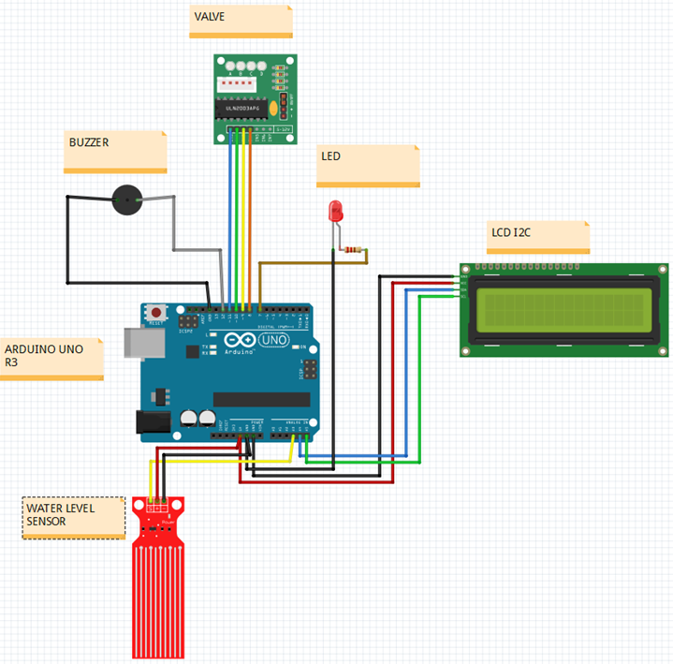

Figure ::Design 1

**Design 2**

In this design we combined three systems of design 1 and replaced the valves with pumps then we needed to add another two important components (HC-05 - Bluetooth Module and L298N motor driver) to control speed and direction of pumps.

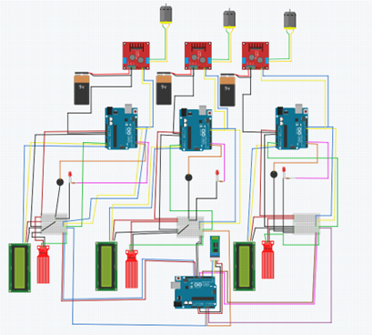

Figure ::Design 2

**Design 3**

In this design we replaced liquid crystal LCDs to 4-Digit-7-segment (TM1637). To have lower cost and lower number of components then we add another two important components (DS3231 and ESP32) to know the real time and to use Wi-Fi to transfer data from application to the system finally we remove HC-05 because we used Wi-Fi

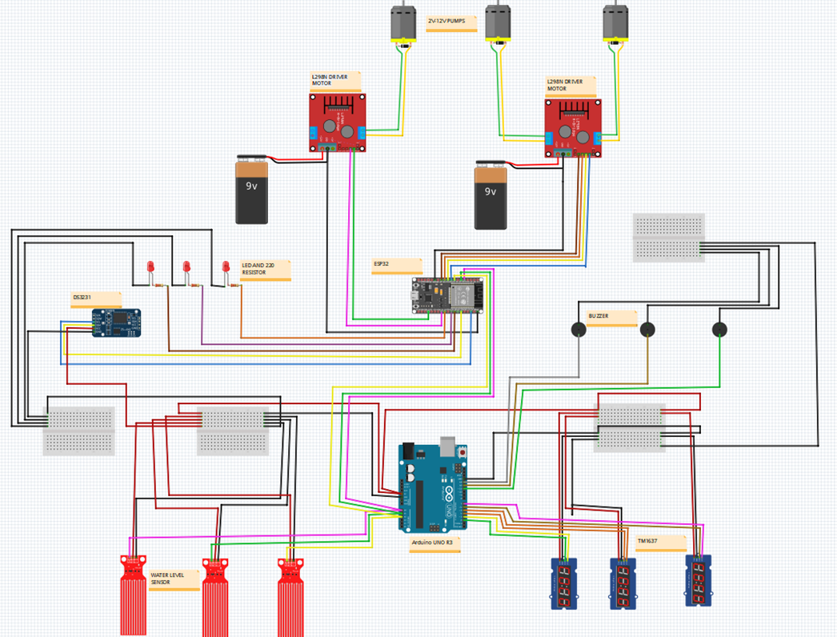

Figure ::Design 3

**Design 4**

This design is about the connection between all components that needed to make a system of one medicine box.

In this design we replaced the water level sensor with ultrasonic sensor because the water level sensor does not read actual data.

Finally, we added an LCD screen to display the actual date and time.

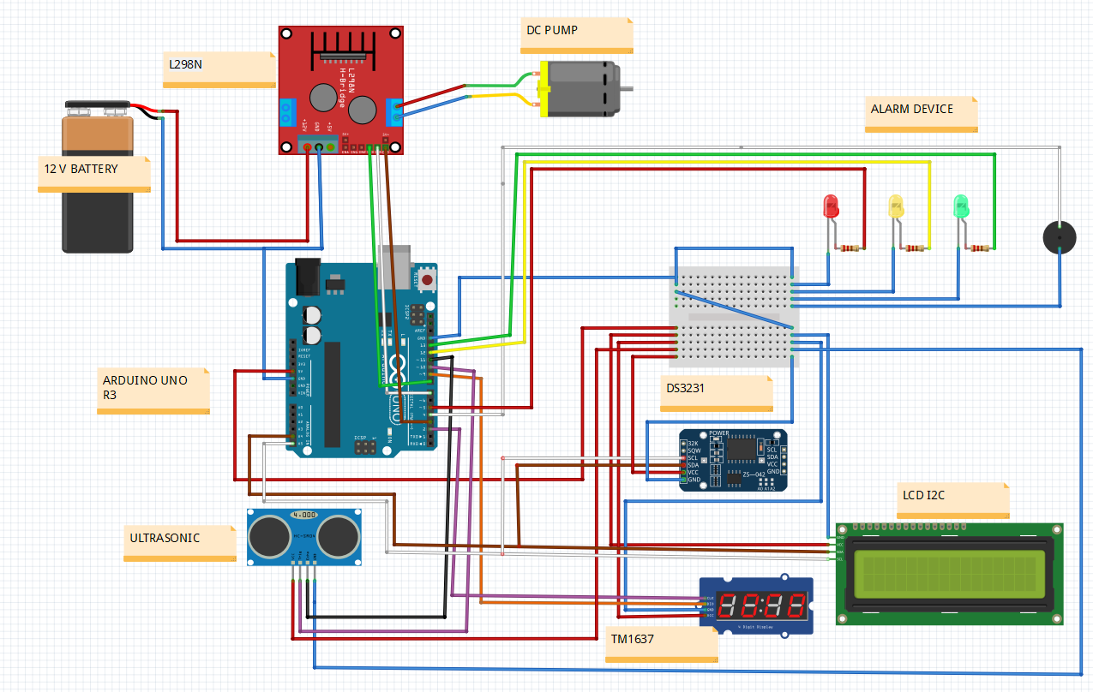

Figure :Design 4

**Design 5**

After conducting many experiments, we have come to this design

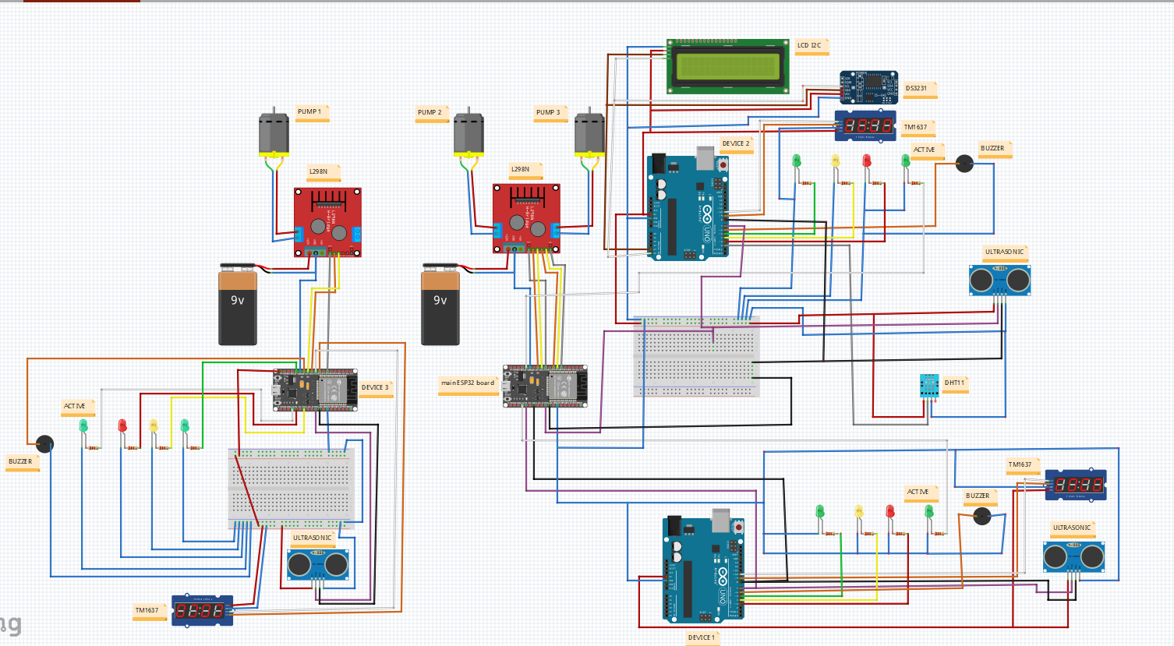

Figure :Design 5

## 3.4 Web application and system flowchart

### 3.4.1 Application flowchart

In the beginning, you need to have a email and password when you start the application, the application will ask about your user email and password then check if you user or admin if you are user then you can do many function for example add patient or read about how dose the system work and etc. if you admin can do different tasks for example add new user or delete user etc. else you cannot log into the application.

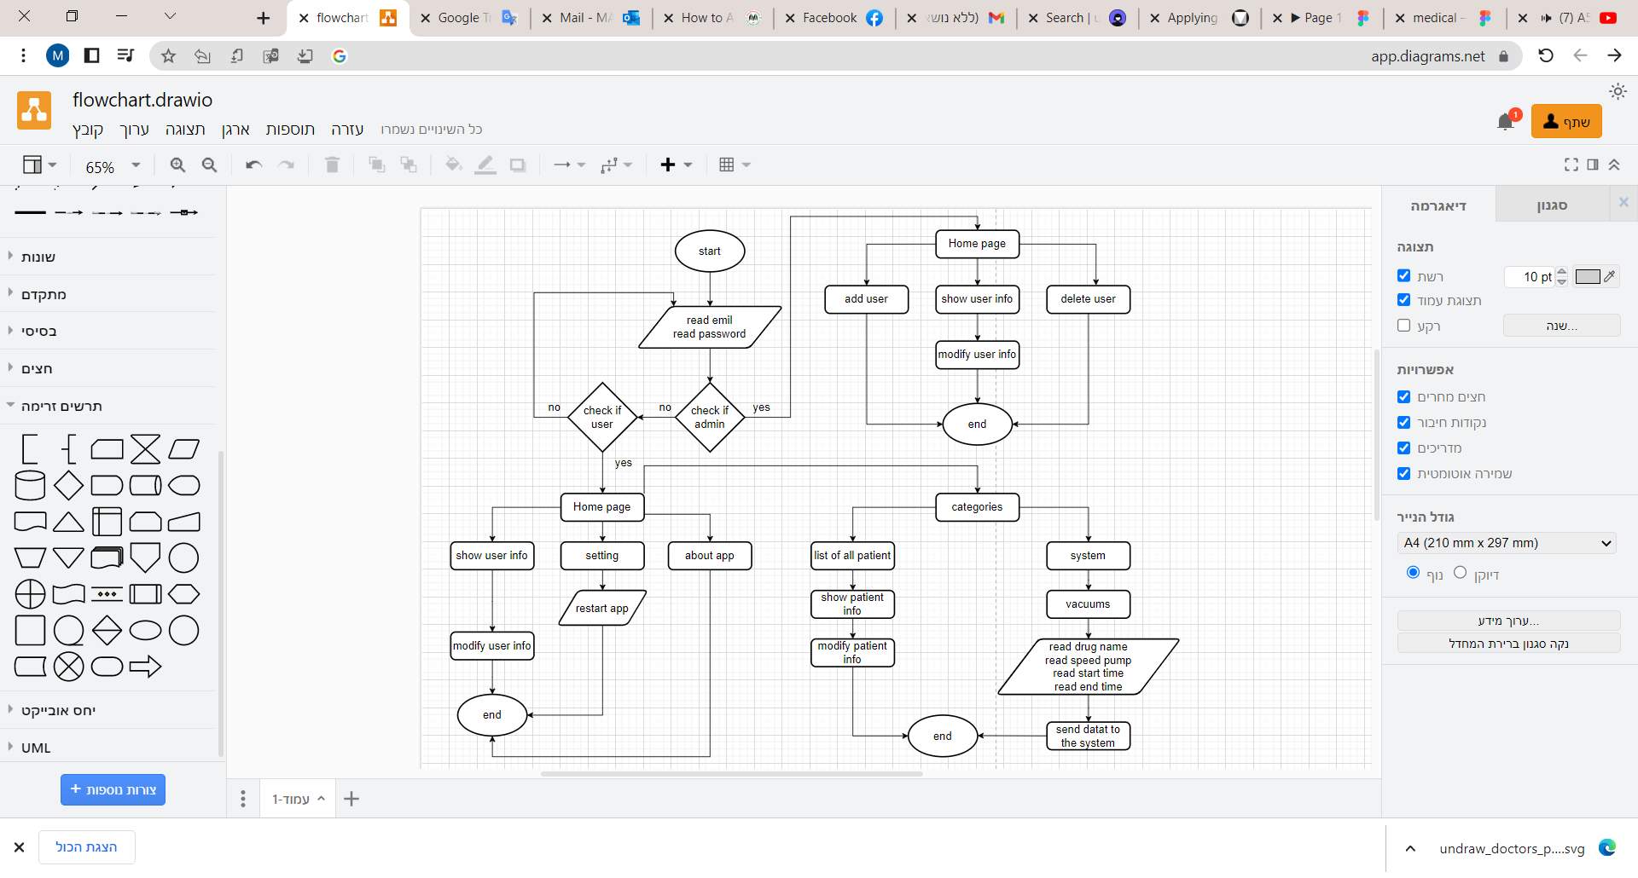

Figure :application flowchart

### 3.4.2 system flowchart

When the process starts, the system measure amounts of drugs then compare this value with minimum value can read it if minimum value is greater than we have an error in the system, the system turn on alarm system (red LEDs and Buzzers) and send error message to all users to fixed it and display the values in 4-Digit-7-Segment (TM1637).

Else, the system read the start time and real time then compares them if have different values then stay to be same values after make same values the system turns on pumps and check if have any error if have it then stop pumps and fixed the error and start at the beginning.

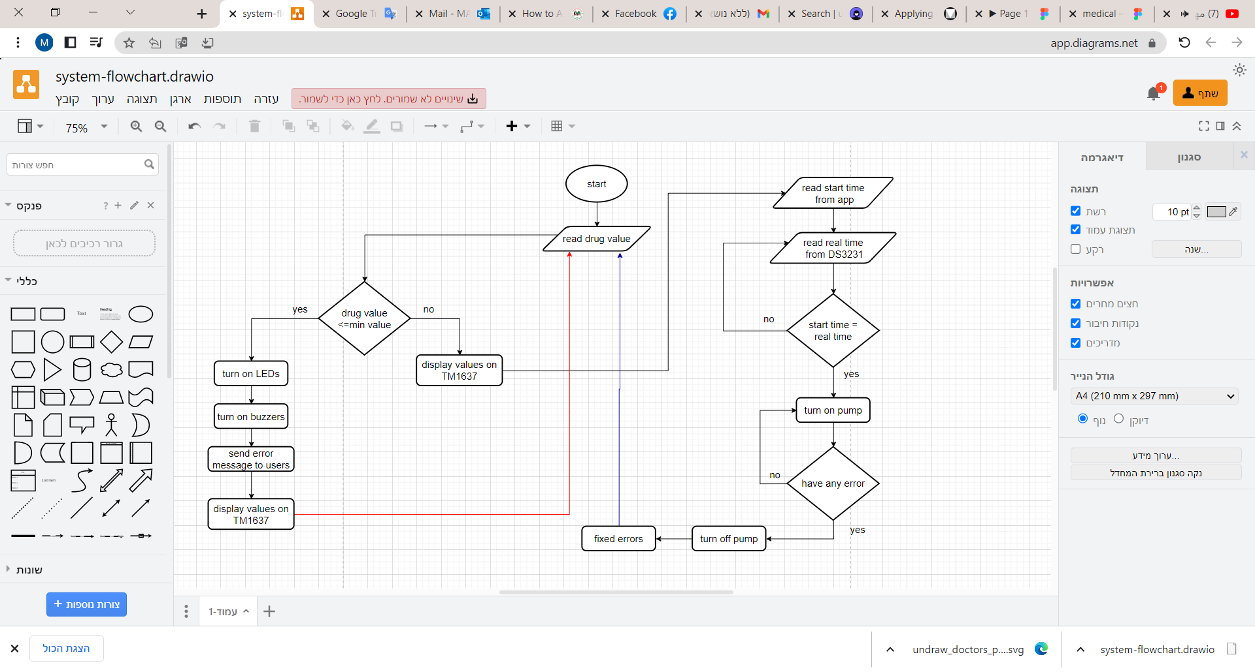

Figure :system flowchart

## 3.5 Use-Case Diagram

In what follows we will illustrate the use cases for the user who represents the doctor and the patient.

**Firstly the User (Doctor/ Nurse) use case:** In the **figure 47** down below you can see the functions or features that the user has like logs in when he had his Email and password given from the Admin previously and he can edit some of his data in future like phone number or anything else but not all of his data, Insert a new patient that if this patient is not in the database because he came unexpectedly and update this data in future if needed, and the most important thing he can do is create and manage the healing process for every on demand that the patients need and by this feature he can control the machine and transmit the data between the software and hardware parts.

**Finally, the admin use case:** In the **figure 48** down below we can see what functions that the admin can do like logging into the application and view all the users list, inserting a new user to the database, by that we can say this admin can have the privilege to access the database and manage it. [28]

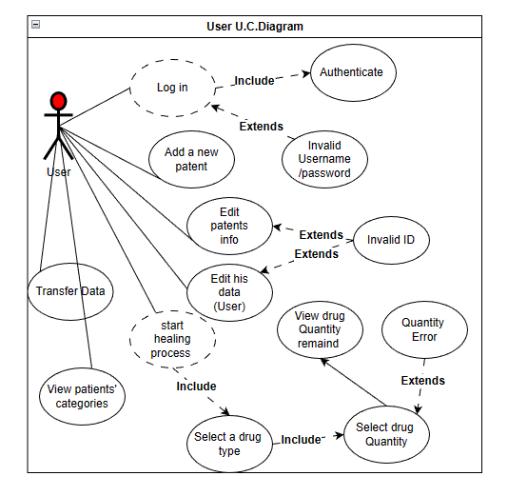

Figure :user U.C Diagram

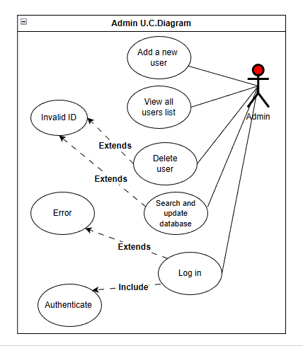

Figure :admin U.S Diagram

## 3.6 State Diagram

In this part we will discuss the system state diagram that we implemented:

In **Figure 49** down below the doctor will be logged in and examined if he is present. In the event that he is not present, the registration will be re-registered. If he is present, he will choose the nurse who will assign him the task.

In **Figure 50** down below we can see When the program is running, the amount of medicine will be taken and shown on TM1637. In the event that the medicine does not reach the low level, the LED and buzzer will be turned on. If it arrives, the system will check the time frequently and if that time equals the time that we specified for this patient the process will start, the pumps will be turned on. If it is not equal, it will return to the state until equality is completed.

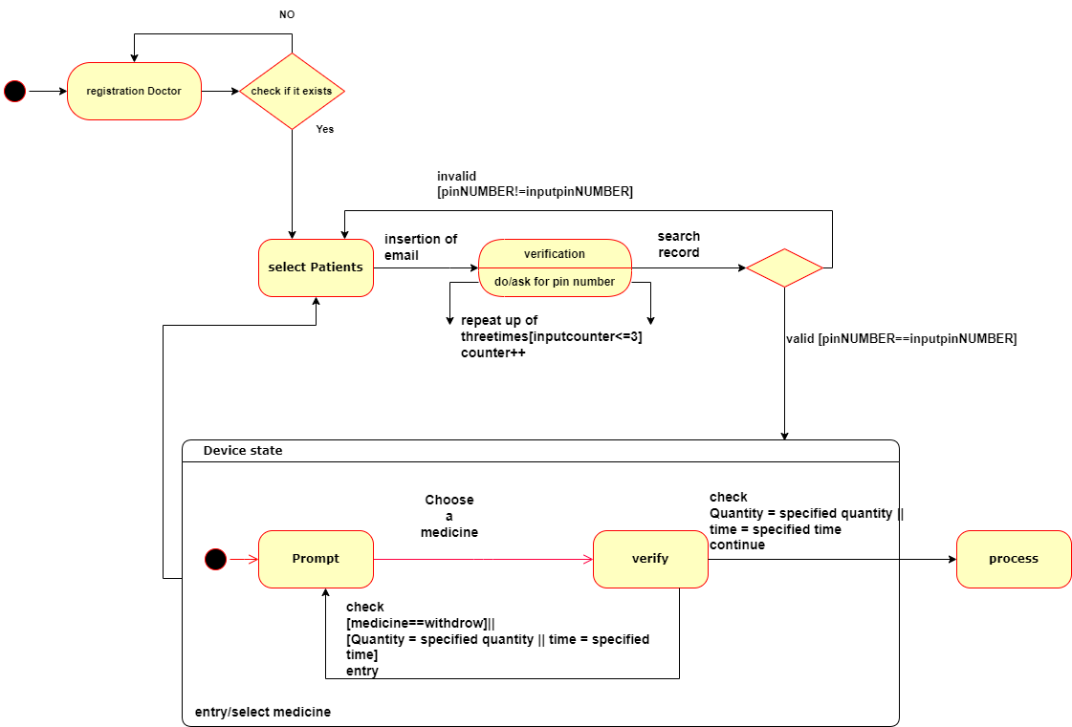

Figure :state diagram.

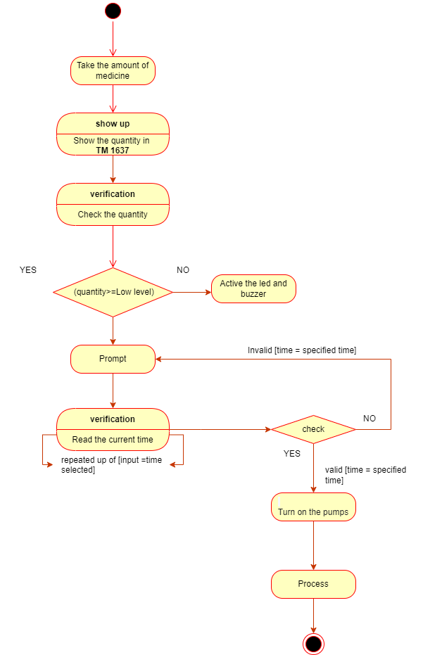

Figure :state diagram 2.

## 3.7 Sequence diagram:

Sequence diagrams are diagrams that detail the interactions between objects as they carryout operations. They provide a visual representation of the order in which messages are sent over time. These diagrams are useful in capturing the collaboration between objects within a system. [30]

In this part we will talk about the sequence diagram that we made in our project document and what interactions that will be between the pages with any action made by the user, so **figure 51** shows the login page and the messages that will appear after any action made after passing it, **Figure 52** shows the diagram for the request of profile page for any user so if this user wants to edit his data shown in his profile page we will move to **figure 53** and see the interactions that's will happen in the app while the editing process. [30]

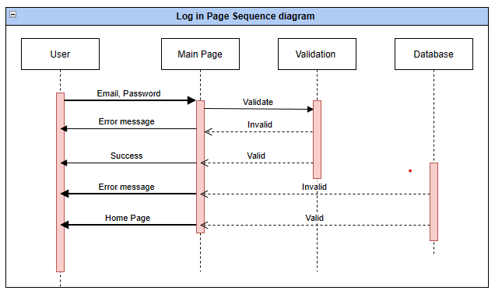

Figure :login page sequence diagram.

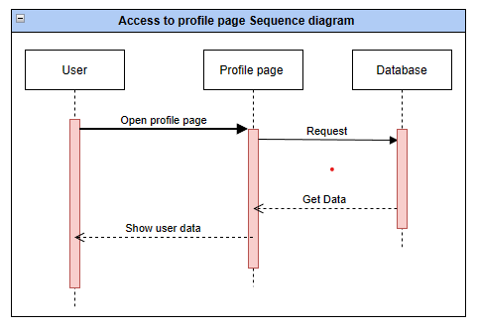

Figure :Profile page sequence diagram.

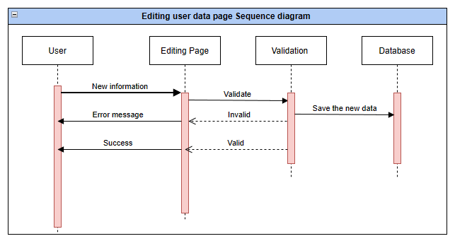

Figure :Editing profile data sequence diagram.

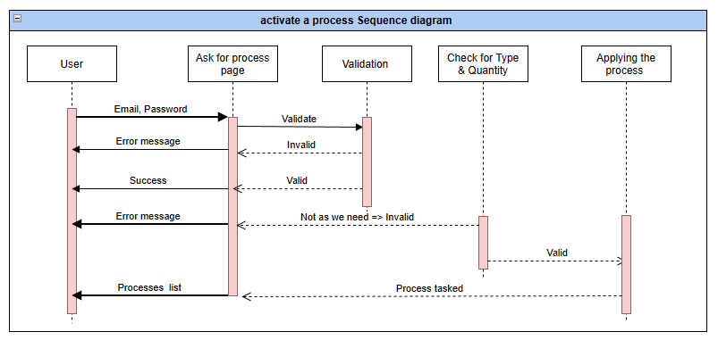

Figure :Make process sequence diagram.

## 3.8 ERD (Entity Relationship Diagram):

In this part we will discuss what ERD we have, what are the tables that will be added to our application database and all the relationships between each table. So the Figure 55 displays all the tables in the database and the relationships between it like we have a relation many processes to one doctor, One admin to many doctors, One doctor to many patients … etc., In the other **Figures from 56 to 61** that shows the variables that's in every table like table doctor in **Figure 56** it contains (**ID, SSN, Name, Department, Photo, Password, Phone number, Email and Password.**) so and so in the other tables.

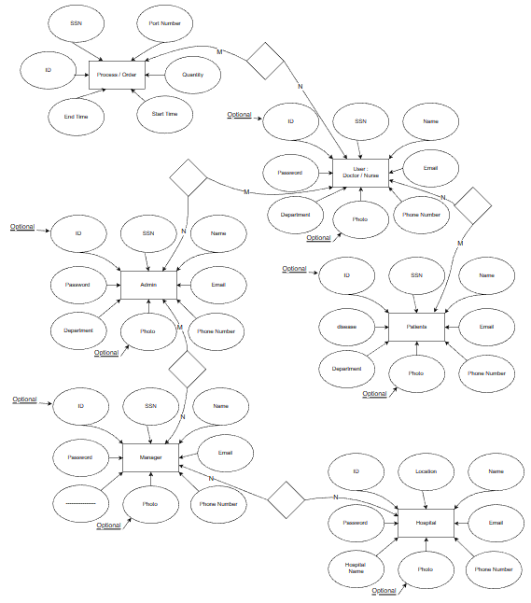

Figure :Entity relationships diagram.

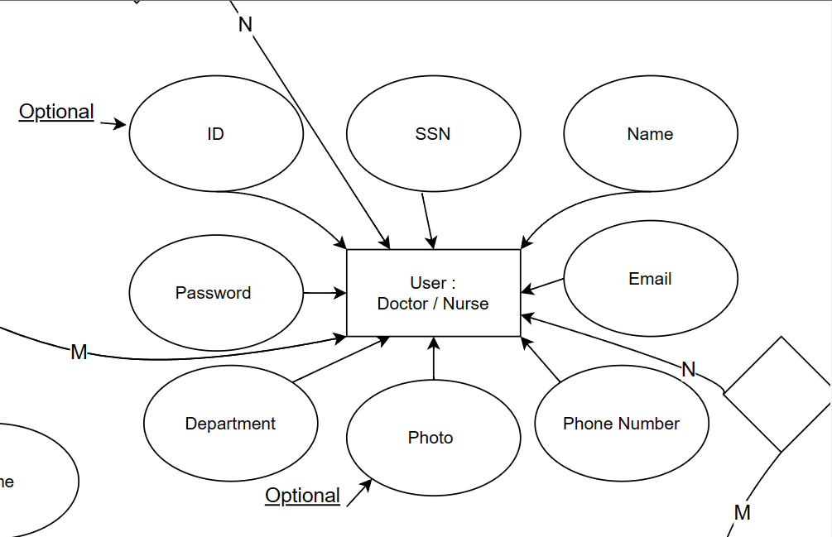

Figure :User E.R Diagram.

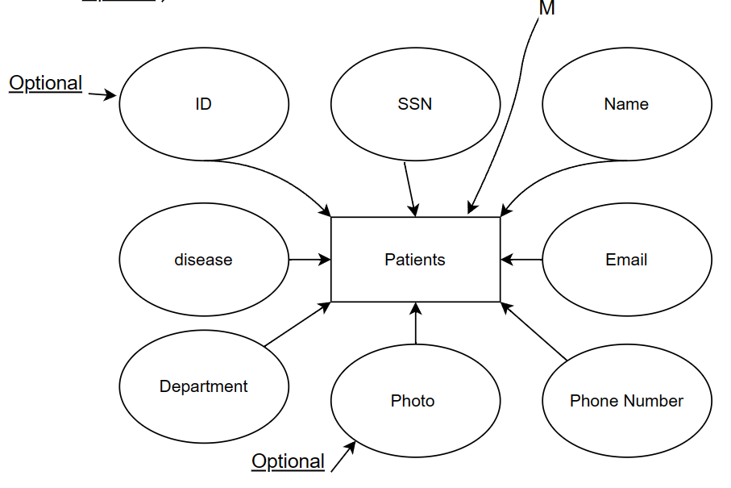

Figure :Patients E.R Diagram.

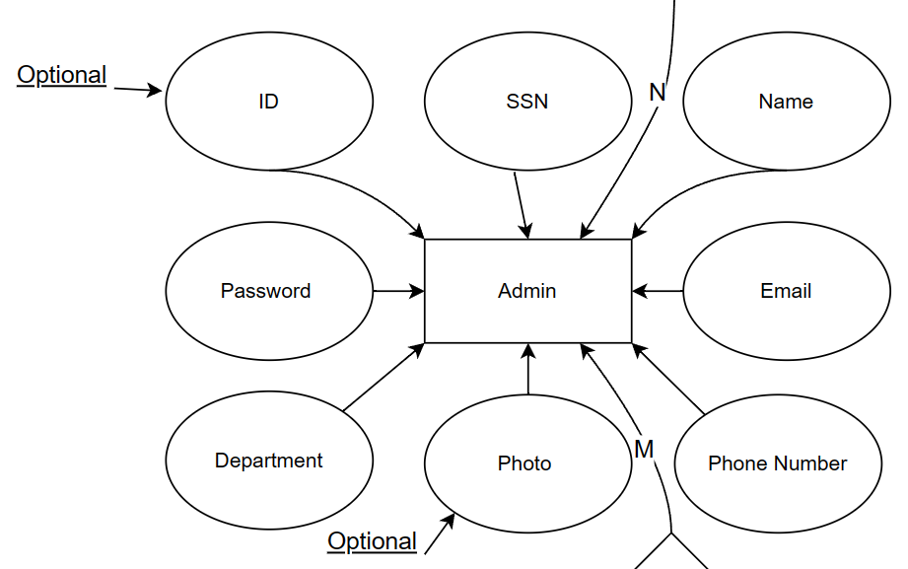

Figure :Admin E.R Diagram.

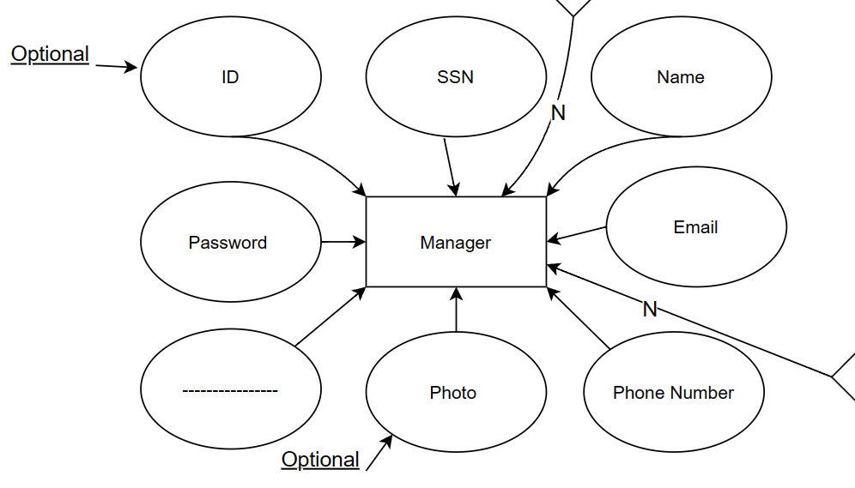

Figure :Manage E.R Diagram

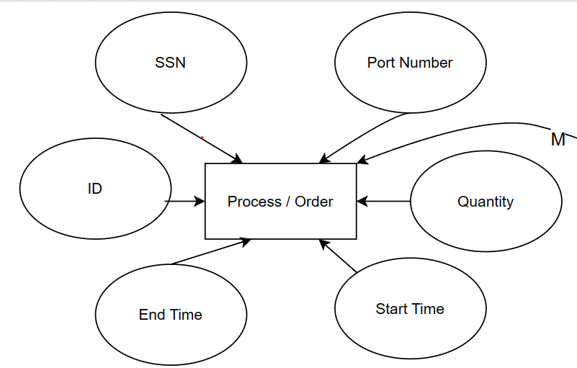

Figure :Process E.R Diagram.

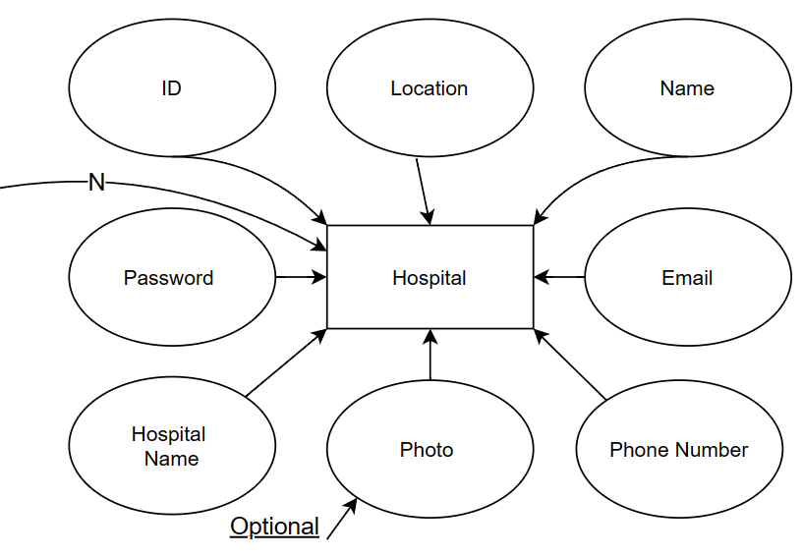

Figure :Hospital E.R Diagram.

## 3.9 UML class diagram

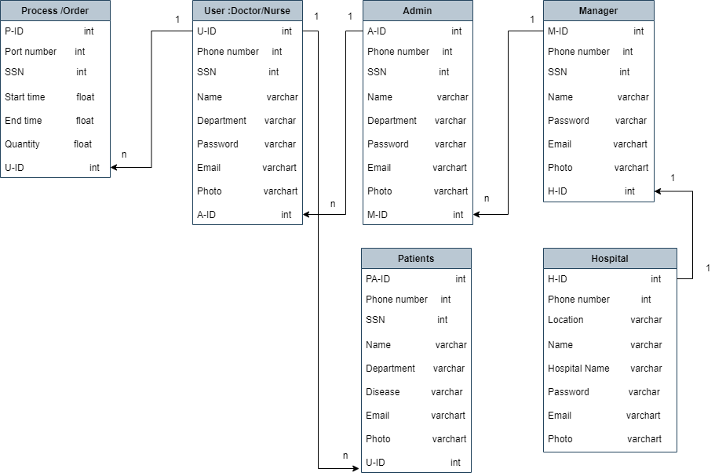

Figure :UML class diagram

## 3.10 System Analysis and Optimization

At first, we considered using valves, screens (LCD I2C) to display the amount of medicine, a water level sensor, and an alarm device for one medicine box. However, after consulting with doctors about liquid medicines, we realized the need for pumps and revised the design to include three tubes for three different types of medicines. During the project, challenges arose, including transferring information from the application to the device via Bluetooth, managing multiple sensors and pumps, ensuring real-time functionality, using the same screens for multiple inputs, and the cost increase due to hardware resource requirements.

This is where challenges began to arise:

● The main challenge was how to transfer data from the application to the device, which was solved through the use of Bluetooth.

● The use of multiple, repeating sensors such as the Arduino UNO R3 posed a challenge.

● Simultaneously using pumps and valves was also a challenge.

● Ensuring real-time data accuracy without being affected by power outages was a concern.

● Displaying data on multiple screens for the same inputs was also a challenge.

● The limited range of Bluetooth was a constraint.

● It's worth noting that the use of additional hardware resources resulted in a significant increase in project cost.

After evaluating all the issues, we decided to simplify the device by:

● Replacing multiple Arduino UNO R3 with a single ESP32

● Switching to digital screens, as they can handle different inputs

● Using the built-in Wi-Fi of the ESP32 instead of Bluetooth

● Eliminating valves as the pumps serve the same purpose

● Including a DS3231 to display real-time information

After starting the process of connecting and assembling the sensors with each other, this did not result in any error according to the third design, but after operating the device, a big problem appeared, which is that the sensor measuring the water level was inaccurate, as the water needs some time to dry from the sensor

From here, new challenges began to emerge, and we began to receive many questions, including:

How can this problem be solved and is there a solution in the first place

After referring to the experts in this field, we concluded that the ultrasonic sensor can be used as an alternative solution

But here the problem has become more and more complicated as the ultrasonic sensor needs more inputs and outputs than the water level sensor

The outputs on the arduino board are not enough to connect all the sensors

From here, we came out with a solution, which is to divide the device into 3 sub-devices and a primary device that controls all devices

With these changes, we arrived at design 5. This design was more cost-effective and required fewer resources compared to the previous design, and had fewer drawbacks.

# CHAPTER 4: RESULTS AND DISCUSSIONS

## Results

After careful consideration, we have decided to adopt the fifth design for the device. Also, after encountering numerous issues related to the design of the application, we decided to adopt the previously mentioned design.

In the beginning, we started to connect each sensor separately to understood how its work.

After connected the water level sensor and tried if it works correctly, a big problem occurred which is the sensor dose not read the real value because, the water needs some time to dry, so the sensor gets confused.

So, we want a solution to solve this problem.

The solution was to replace the water level sensor with ultrasonic sensor

After solved the problem we tried to connect all the sensor together according to the fourth design.

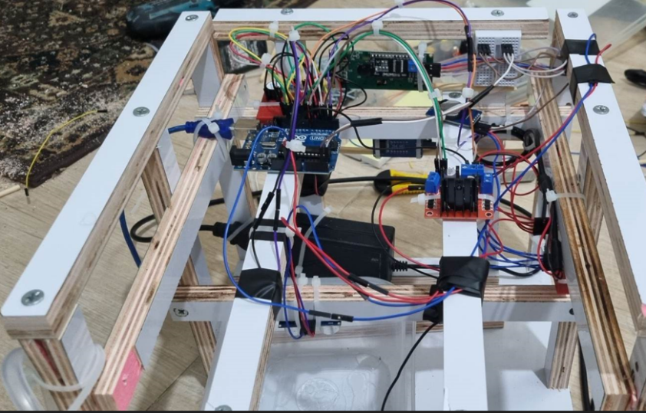

Figure :design 3 connection 1

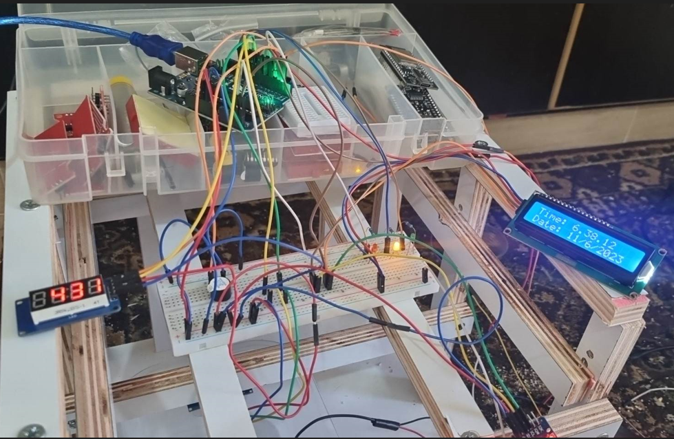

Figure :design 3 connection 2

After running the device, we have obtained the desired results.

Some of results: -

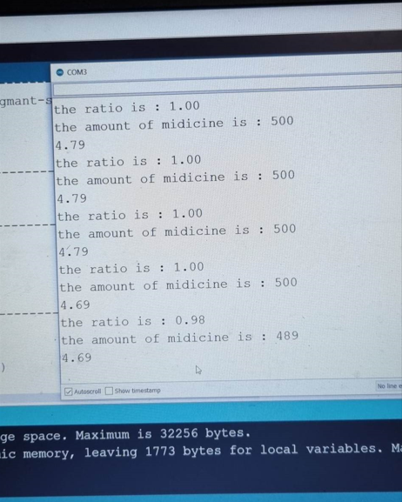 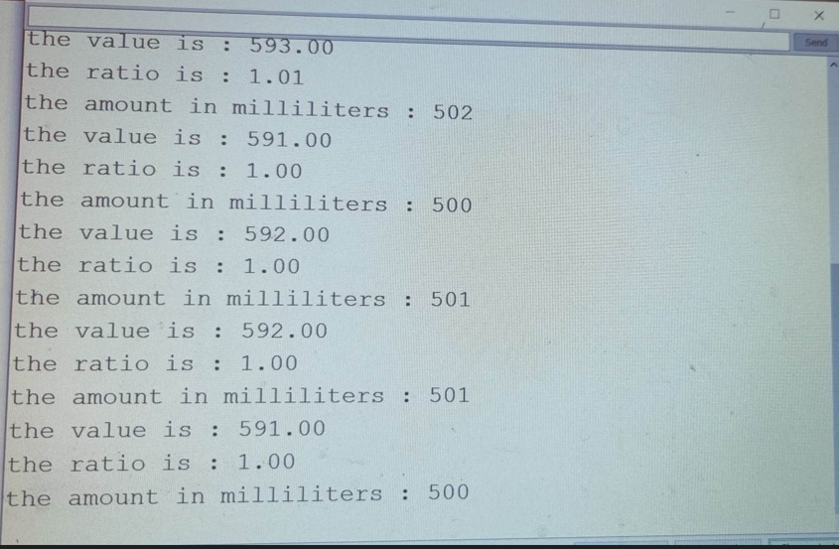

Figure :design 3 results 2 Figure :design 3 results 1

After obtaining satisfactory results, we can connect the entire device according to fifth design without making mistakes.

We solved the connection between hardware and software by using Realtime Database (firebase) and Wi-Fi

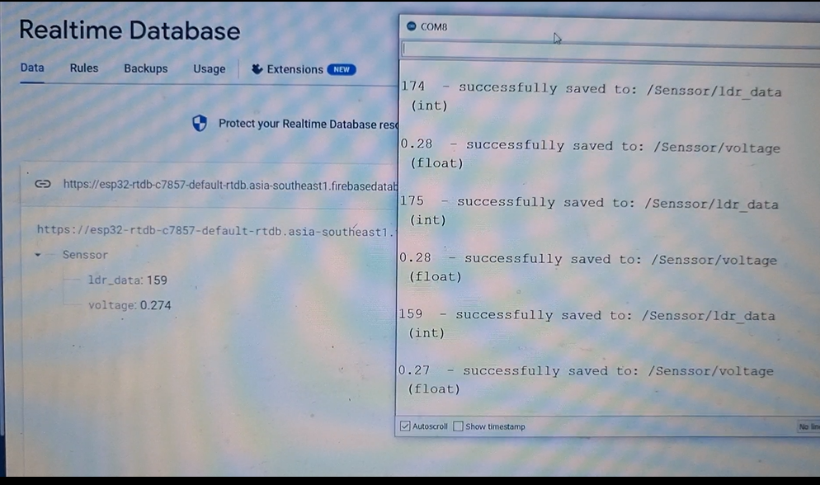

Figure :Realtime database results

The final design is:

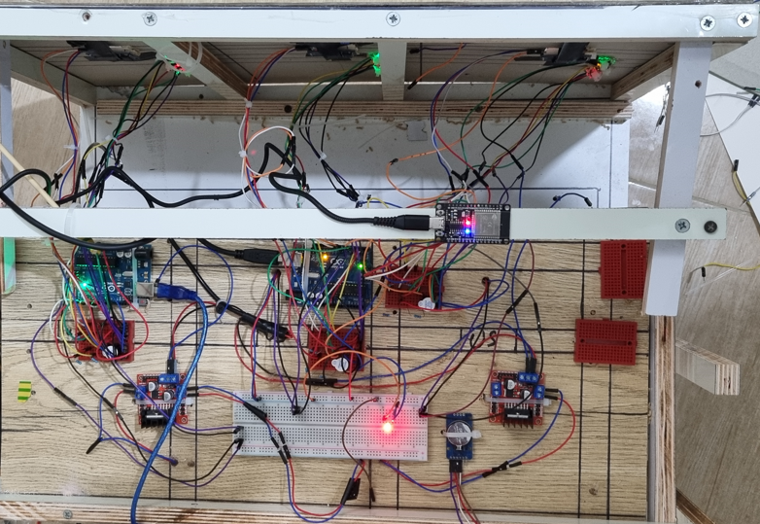

Figure :final design 1

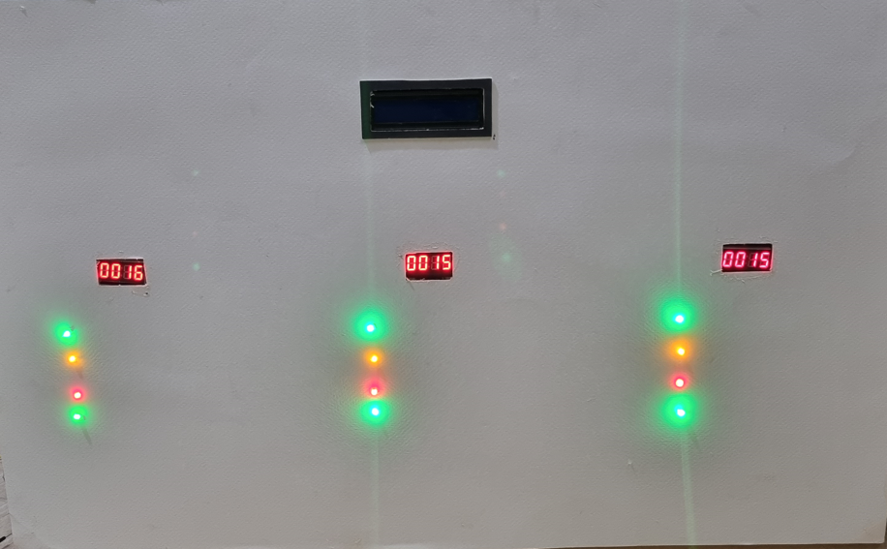

Figure :final design 2

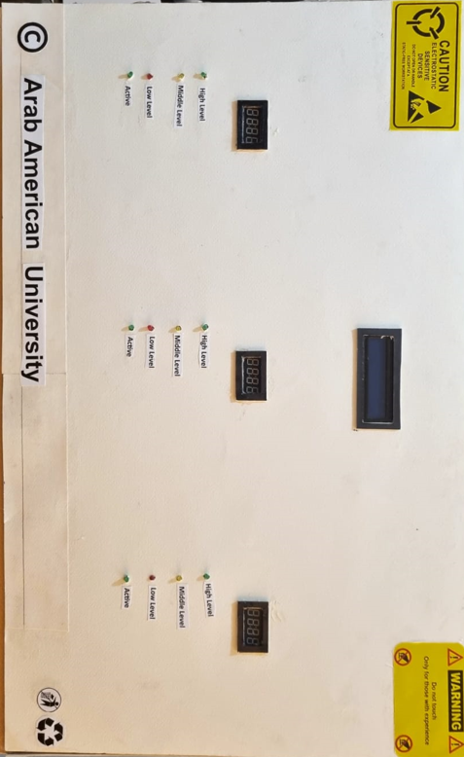

Figure :final design 3

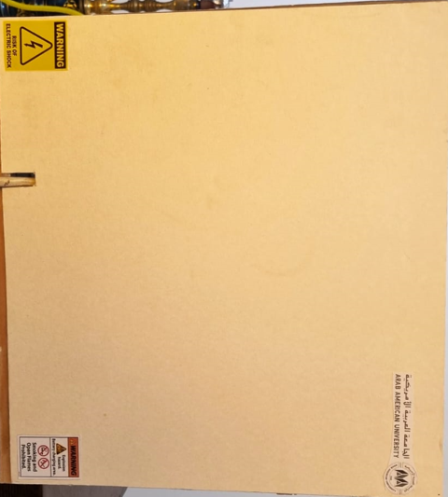

Figure :final design 4

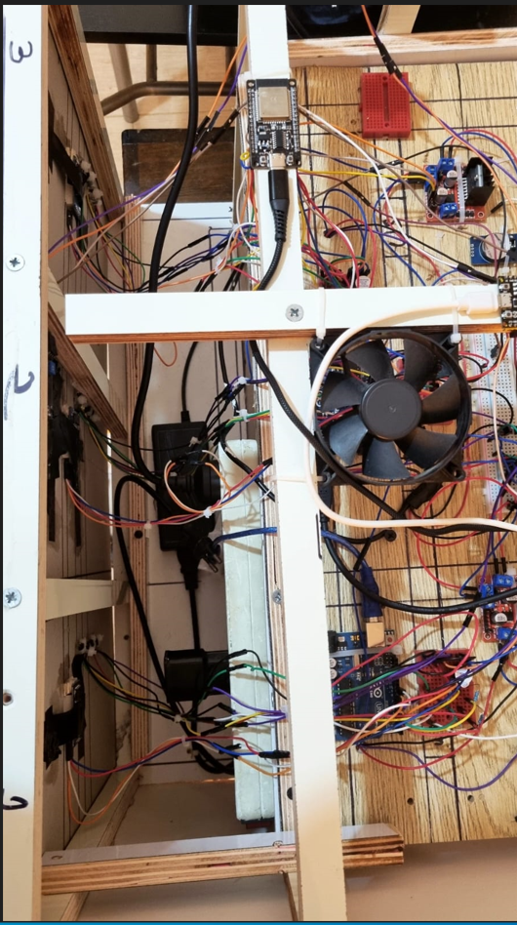

Figure :final design 5

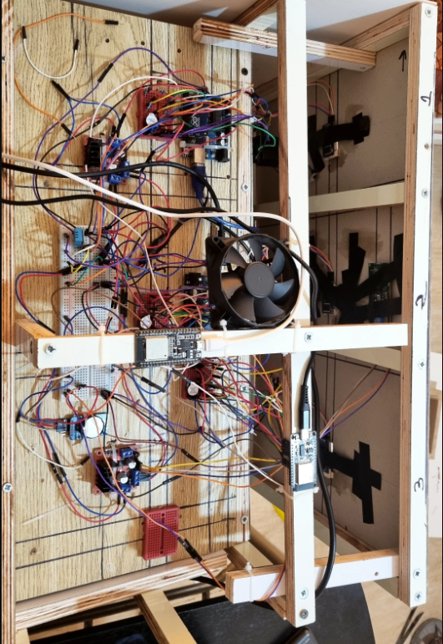

Figure :final design 6

## Discussions

The process of choosing the right components for our device was a challenge for us. However, after seeking the expertise of professionals in the field and carefully considering the available options, we were able to identify the appropriate components and tools to use. Despite this, several problems arose during the development of the device, such as the difficulty in transferring information from the application to the device, the need to use multiple sensors, and the cost of hardware resources. Through persistent effort and problem-solving, we were eventually able to arrive at the most suitable design, the third design, which proved to be the most cost-effective and efficient option among the three designs.

The development of the web application was another hurdle we had to overcome. Initially, our lack of knowledge in web application programming made it challenging for us to determine which programming language and software to use. After extensive research and careful analysis of the various languages and programs available, we ultimately decided to use React and Visual Studio Code, which proved to be the most suitable for our needs. This choice allowed us to effectively address the problems that arose during the application development and build a user-friendly and functional web application.

# CHAPTER 5: Project Management

## 5.1 Tasks, Schedule and Milestones

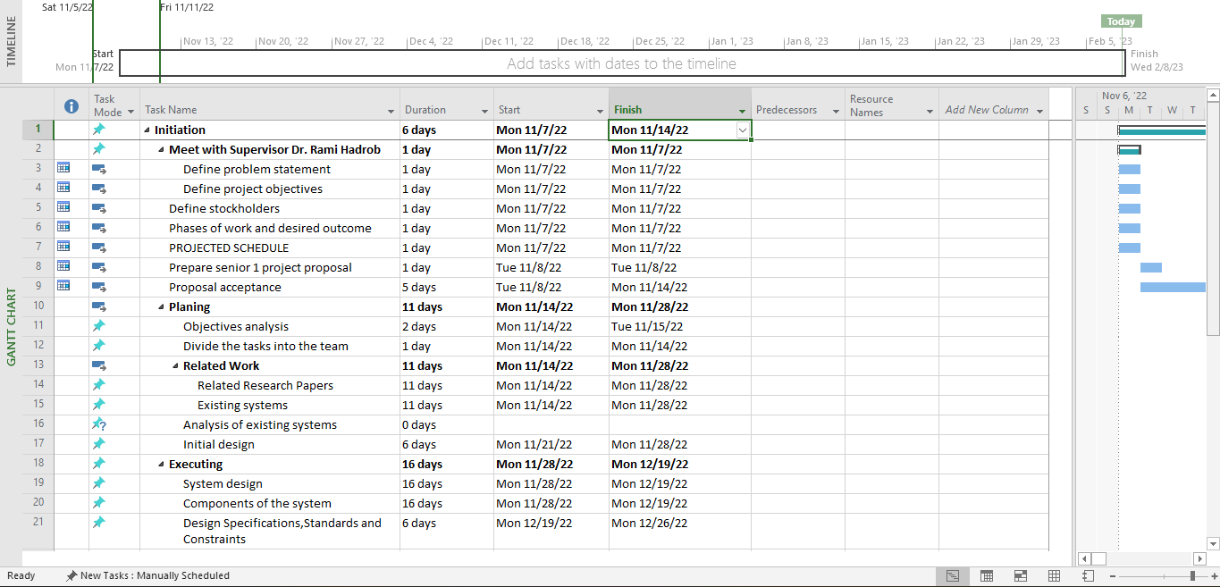

Figure :schedule part A

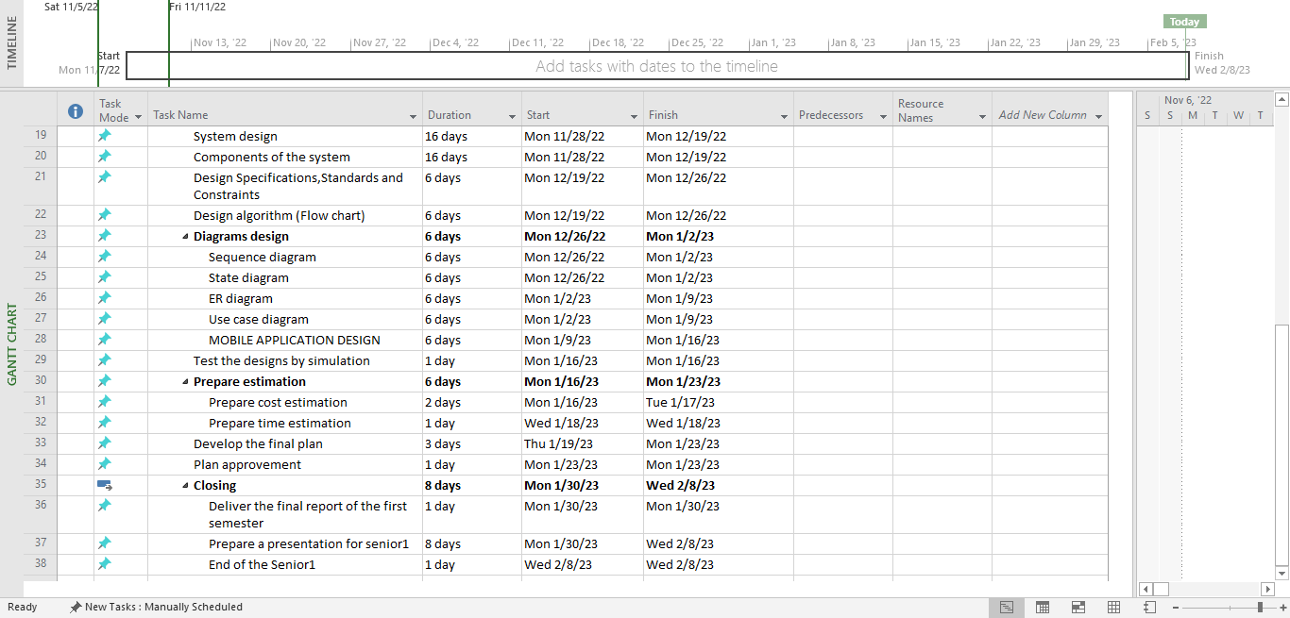

Figure :schedule part B

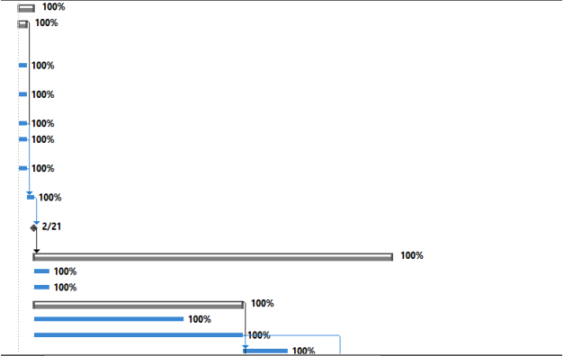

Figure :schedule part C

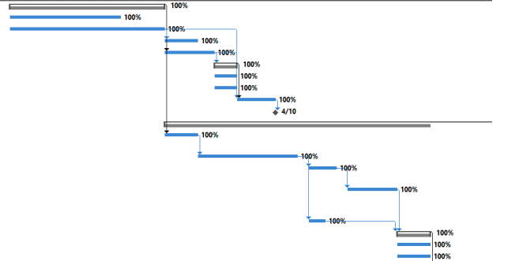

Figure :schedule part D

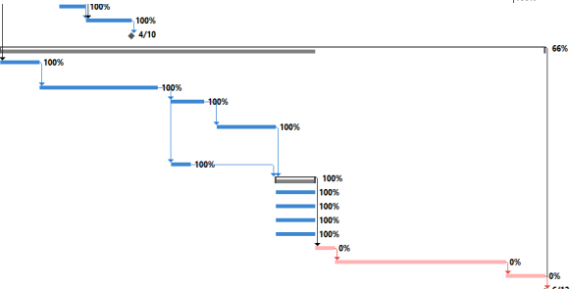

Figure :schedule part E

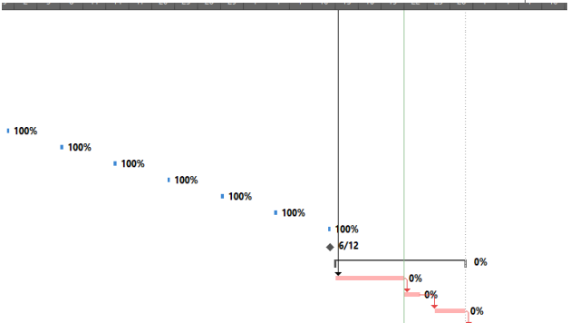

Figure :schedule part F

## 5.2 Resources and Cost Management

Table :cost of senior project items

|  |  |  |  |  |
| --- | --- | --- | --- | --- |
| **Item** | **# Unit** | **Unit Cost** | **Subtotals** | **Comments** |
| ESP-32 | 2 | 8.5$ | 17$ |  |
| Mini water pump | 3 | 8.6$ | 25.8$ |  |
| L298N driver motor | 2 | 2.8$ | 5.6$ |  |
| 12V-2A power supply | 1 | 11.9$ | 11.9$ |  |
| Red LEDs | 3 | 0.2$ | 0.6$ |  |
| Yellow LEDs | 3 | 0.2$ | 0.6$ |  |
| Green LEDs | 6 | 0.2$ | 1.2$ |  |
| Resistor 220Ω | 12 | 0.2$ | 2.4$ |  |
| 1N4004 Diode | 3 | 0.25$ | 10ps⇒2.5$ |  |
| Buzzer | 3 | 0.33$ | 10ps⇒3.3$ |  |
| Water level sensor | 3 | 3.4$ | 10.2$ |  |
| DS3231 | 1 | 4.5$ | 4.5$ |  |
| TM1637 | 3 | 2.88$ | 8.64$ |  |
| Arduino Uno R3 ATmega328P + USB | 2 | 15$ | 30$ |  |
| Wire M-M | 120 | 40ps⇒5.6$ | 16.8$ |  |
| Wire F-M | 160 | 40ps⇒5.6$ | 22.4$ |  |
| Breadboard | 1 | 5$ | 5$ |  |
| Half -breadboard | 5 | 5ps⇒10$ | 10$ |  |
| MAXEL ML2023 | 1 | 5$ | 5$ |  |
| DHT11 | 1 | 5$ | 5$ |  |
| Ultrasonic sensor | 3 | 8$ | 24$ |  |
| Subscription fees of fritzing | 12 | 1-month⇒25$ | 300$ |  |
| Other tools | ? | ? | 150$ |  |
| Total senior project estimate |  |  | 662.44$ |  |

## 5.3 Lessons Learned

1. Before starting the project, it is important to research the components and tools needed in the process of building a medical semi-automated system for injectable drugs.
2. The importance of collaboration between team members in different fields can help to find solutions to challenges that may arise in the process of building a medical semi-automated system.
3. Using the latest technology such as ESP-32, Wi-Fi, and digital screens can help to improve the functionality of the medical semi-automated system.
4. Every component of the system must be carefully chosen and assembled to ensure that the system functions correctly and is safe for use.
5. Finding the right balance between cost and quality is important when building a medical semi-automated system.

# CHAPTER 6: Impact of the engineering solution

## 6.1 Economical, Societal and Global

We plan to import second-hand tools from overseas as they are more cost-effective than purchasing them domestically. By implementing a system that controls the administration of medication through an app, we aim to reduce the risk of harm to patients by ensuring accurate dosing and timing. This not only streamlines the process, but also frees up medical personnel from having to constantly monitor and administer the medication. Our project has great potential for widespread adoption in hospitals, as there is a high demand for safer and more efficient methods of administering medication. This not only has the potential to recoup our investment but also has the potential to make a significant positive impact on patient care.

This semi-smart control system will aid in the development of a substantial number of devices that can be exported globally. Our goal is to receive widespread acceptance among medical professionals, making their work easier and more efficient. The doctor can control the device remotely via a mobile application, except in emergency situations or when there are malfunctions. Our project also aims to create job opportunities by producing and selling the sensors and control devices required for the project, and by hiring programmers to develop the mobile application. This will have a positive impact on both our community and the world.

## 6.2 Environmental and Ethical

Our Medical Semi-Automated System aims to aid in the administration of injectable drugs. By utilizing this system, medical professionals can remotely control the drug delivery process, reducing their workload and increasing efficiency, except in emergency situations or in case of malfunctions. The project will create job opportunities in the fields of device production, sales and mobile application development, resulting in a positive impact on society.

## 6.3 Other Issues

We aim to implement all the options outlined in this project and explore alternative approaches where necessary. The main challenges include delays in obtaining equipment and sensors, utilizing different sensors with varying specifications, and integrating these sensors effectively. During the next semester, we will commence development of the prototype, including a mobile application [8].

# CHAPTER 7: CONCLUSIONS and RECOMMENDATIONS

## 7.1 Summary of Achievements of the Project Objectives

Our graduation project, the Medical Semi-Automated System for Injectable Drugs, is a response to the current era of technological advancement and its potential to improve the medical field. The system aims to address problems such as increased pollution, population growth, hospital overcrowding, and climate change by providing an accurate and efficient method for administering medicine. The system will consist of a device installed in the patient's room, equipped with sensors and connected to an Arduino board and a mobile application. The device will monitor and alert for any defects in the medicine delivery process, and the mobile application will receive and display real-time data from the sensors, as well as allow remote control. The application will also compare readings with the database and send notifications to the doctor if a defect is detected, allowing for continuous improvement. Our goal is to have the project approved and widely adopted by relevant institutions.

## 7.2 New Skills and Experiences Learnt

1. The most important thing we learned is how to manage our time accurately, how to divide the workload between us, and working in a team.
2. We learned how to connect the sensors to the Arduino board.
3. We learned how to design a circuit.
4. We learned how to use the Fritzing application that helped us to give a better idea of the interconnections of the components and if they will work together
5. Another skill that we gained is the ability to design web applications using Figma, an application that led us to have a better understanding of the project requirements since most of the functional requirements are shown in the web application, which is what our system needs to display for the user.
6. We learned how to design the algorithm that our system will work on using the draw-io application. This will help us understand how the components will communicate with each other and if there are any conflicts or reading delays when combining them into a whole system, one more skill.
7. We learned how to connect any application (web and mobile) with our device via firebase and Wi-Fi connections

## *7.3* Recommendations for Future Work

Having sufficient time and resources, requesting equipment before starting the project, studying it, and determining the appropriate type for the project. We recommend shedding more light on technology in the field of medicine, because if it receives more attention, it will solve many problems and facilitate human life.

# REFERENCES

[1] Infusion pump: (Mon 14/11/22 14:35)

[INFUSION PUMP (Model SeaMed KL-8052N) – Denizler Medikal](https://www.denizlermedikal.com/language/ar/seamed-kl-8052n-infuzyon-pompasi/#1545656983606-ceebedbe-737f2d8a-2ce13df0-34a6090c-df5c)

[جهاز مضخة الحقن (arabiomed.com)](https://www.arabiomed.com/2020/10/infusion-pump.html)

[2]. Injection pump device: (Mon 14/11/22 15:15)

[Advantages & Disadvantages of Syringe Pumps | Chemyx Inc](https://chemyx.com/support/knowledge-base/application-reference-by-topic/advantages-and-disadvantages-of-syringe-pumps/)

[3]. Water level sensor with Arduino: (Wed 16/11/22 17:00)

<https://mytectutor.com/water-level-sensor-with-arduino>/

[4]. Controlling pumps with Arduino: (Fri 18/11/22 16:20)

<https://www.sensingthecity.com/tutorial-controlling-submersible-pump-with-arduino>

[5].hk100i infusion pump: (Thurs 24/11/22 18:00)

<https://bloodline-equipment.com.au/uploads/hk100i-infusion-pump-user-manual-20130528.pdf>

[6]. ESP32 and DS3231 connection: (Sun 20/11/22 17:35)

<https://how2electronics.com/esp32-ds3231-based-real-time-clock/>

[7]. Breadboard: (Mon 28/11/22 18:00)

<https://learn.sparkfun.com/tutorials/how-to-use-a-breadboard/all>

[8]. Diode: (Mon 28/11/22 18:30)

<https://www.electrical4u.com/diode-working-principle-and-types-of-diode/>

[9]. Resistor: (Tues 29/11/22 16:30)

<https://www.physicsclassroom.com/class/circuits/Lesson-3/Resistance>

[10]. Transistor: (Tues 1/12/22 17:00)

<https://learn.sparkfun.com/tutorials/transistors/all>

[11]. LEDs: (Sat 3/12/22 12:00)

<https://en.wikipedia.org/wiki/Light-emitting_diode>

[12]. Active Buzzer: (Sat 3/12/22 12:07)

<https://www.instructables.com/Active-and-Passive-Buzzer-Discussed/>

[13]. Pump 5V: (Sun 4/12/22 18:10)

<https://www.mybotic.com.my/motor-and-motor-driver/water-pump/micro-submersible-water-pump-dc-3v-5v>

[14]. Arduino UNO R3: (Tues 6/12/22 14:13)

<https://www.tinyosshop.com/index.php?route=product/product&product_id=224>

[15]. ESP32: (Tues 6/12/22 15:00)

<http://esp32.net/>

[16]. Water Level Sensor: (Wed 7/12/22 15:00)

<https://lastminuteengineers.com/water-level-sensor-arduino-tutorial/>

[17]. Power supply: (Sun 11/12/22 14:00)

<https://www.acopian.com/5v-power-supplies.html>

[18]. L298N: (Mon 12/12/22 14:00)

:<https://www.etechnophiles.com/l298n-motor-driver-pin-diagram/>

[19]. TM1637: (Mon 12/12/22 14:15)

<https://github.com/TeWu/TM1637>

[20]. DS3231 details: (Mon 12/12/22 15:00)

:<https://components101.com/modules/ds3231-rtc-module-pinout-circuit-datasheet>

[21]. ML2032: (Mon 12/12/22 16:00)

<https://biz.maxell.com/en/primary_batteries/CR_18e.pdf>

[22]. android studio (Tues 13/12/22 14:00)

<https://developer.android.com/studio/intro>

[23]. VS Code: (Tues 13/12/22 17:00)

<https://code.visualstudio.com/docs/editor/whyvscode>

[24]. Draw.io: (Tues 13/12/22 18:08)

<https://www.computerhope.com/jargon/d/drawio.htm>

[25]. Fritzing: (Wed 14/12/22 19:45)

<https://en.wikipedia.org/wiki/Fritzing>

[26]. Figma: (Wed 14/12/22 21:37)

<https://www.freecodecamp.org/news/figma-crash-course/>

[27]. functional-vs-non-functional-requirements: (Sun 15/1/23 16:00)

<https://www.geeksforgeeks.org/functional-vs-non-functional-requirements/>

[28]. Use case diagram: (Mon 23/1/23 15:00)

<https://www.lucidchart.com/pages/uml-use-case-diagram>

[29]. State diagram: (Wed 25/1/23 15:00)

<https://en.wikipedia.org/wiki/State_diagram>

[30]. Sequence diagram: (Fri 27/1/23 17:30)

<https://www.visual-paradigm.com/guide/uml-unified-modeling-language/what-is-sequence-diagram/>

# APPENDICES

## Appendix 1: Temperature compensated crystal oscillator

A TCXO (Temperature compensated crystal oscillator) is a crystal oscillator with a temperature-sensitive reactance circuit in its oscillation loop to compensate for the frequency-temperature characteristics inherent to the crystal unit. Epson's are classified into two types. One is a Direct-Type TCXO with a temperature compensation circuit built into the oscillation loop. The other is an Indirect-Type TCXO with a temperature compensation circuit outside the oscillation loop, in which the oscillation frequency is therefore indirectly controlled.

## Appendix 2: Arduino Uno Pinout - Diagram

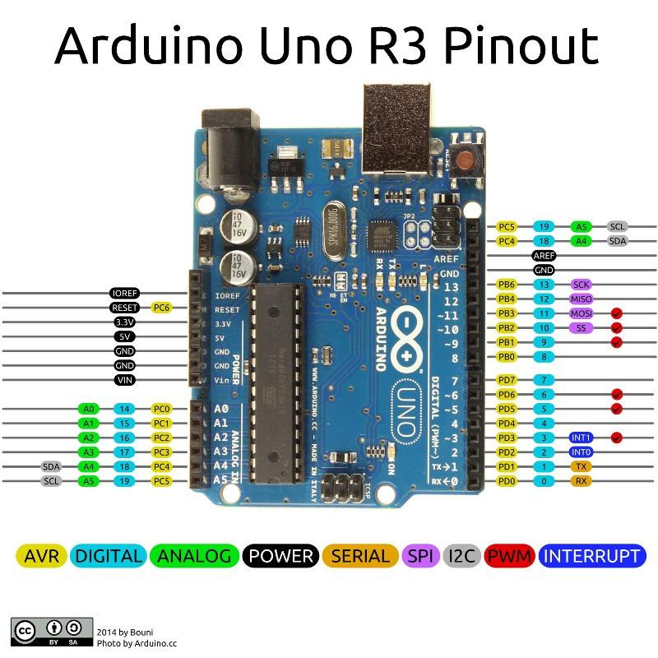

Figure :Arduino UNO R3 pinout

## Appendix 3:-L298N driver motor



Figure :L298N

**VCC -** pin supplies power to the motor. Voltage anywhere between 5 to 35V can be applied. Remember, if the 5V-EN jumper is in place, you need to supply 2 extra volts than the motor’s actual voltage requirement, in order to run the motor at its maximum speed.

**GND -** is the common ground pin.

**5V -** pin supplies power to the switching logic circuitry inside the L298N IC. If the 5V-EN jumper is in place, this pin acts as output and can be used to power up the Arduino. If the 5V-EN jumper is removed, you need to connect it to the 5V pin on Arduino.

**ENA -** pins are utilized to control the speed of Motor A. Supplying this pin with HIGH logic makes the Motor A rotate, supplying it with LOW logic causes the motor to stop. Removing the jumper and connecting this pin to the PWM input let us control the speed of the Motor A.

**IN1 & IN2 -** pins are used to control the direction of Motor A. If IN1 is HIGH and IN2 is LOW, Motor A spins in a certain direction. To change the direction, make IN1 LOW and IN2 HIGH. If both the inputs are either HIGH or LOW, the Motor A stops.

**IN3 & IN4 -** pins are used to control the direction of the Motor B. If IN3 is HIGH and IN4 is LOW, Motor B spins in a certain direction. To change the direction, make IN3 LOW and IN4 HIGH. If both the inputs are either HIGH or LOW, the Motor B stops.

**ENB -** pin can be used to control the speed of Motor B. Supplying this pin with the HIGH signal makes the Motor B turn, supplying it LOW causes the motor to stop. Eliminating the jumper and interfacing this pin to PWM information let us control the speed of Motor B.

**OUT1 & OUT2 -** pins are connected to Motor A.

**OUT3 & OUT4 -** pins are connected to Motor B.

## Appendix 4:- DS3231 RTC module

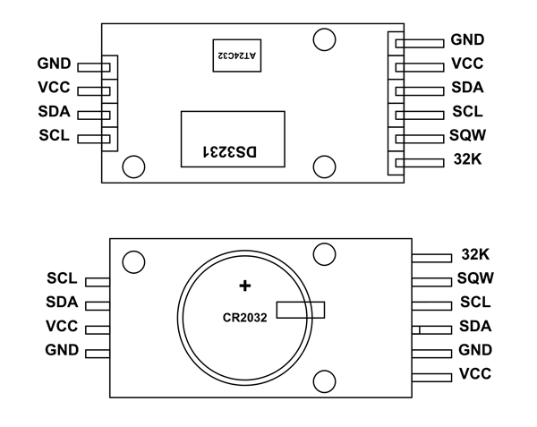

Figure :DS3231

Table :DS3231 Pins Description

|  |  |
| --- | --- |
| **Pin Name** | **Description** |
| **VCC** | Connected to positive of power source |
| **GND** | Connected to ground. |
| **SDA** | Serial Data pin (I2C interface) |
| **SCL** | Serial Clock pin (I2C interface) |
| **SQW** | Square Wave output pin |
| **32K** | 32K oscillator output |